GIS in Water Resources Homework #2 Solution

1. a) Given the following grid of elevations, identify any cells that are pits (sinks) in the grid by drawing a circle around the elevation in that cell. Label the pit cells with the elevation they would have once the pits are filled. Focus only on the ungrayed center cells. The grayed edge cells can by definition not be pits because the elevations off the area shown are not known.

57 | 55 | 47 | 48 | 48 | 50 | 53
53 | 67 | 56 A  39 | 49  39 | 52 | 54 | 42
53 | 52 | 45 | 36 | 37 | 43 | 38
51 | 58 | 40 | 42 | 40 | 39 | 38
55 | 39 | 38 | 38 | 36 | 38 | 38

The pits are indicated. They are filled to the elevation of 39 so that they are the same level as the lowest pour point (green circle). Pits do not need to be raised to a level higher than the lowest pour point.

b) Calculate the slope at grid cell labeled A using
(i) The standard slope function

Grid size = 100m (from last question)
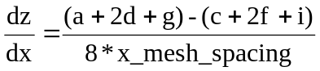
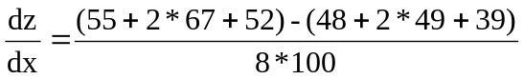
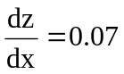
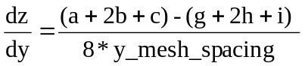
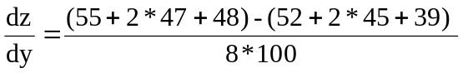
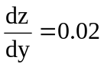

a 55 | b 47 | c 48
d 67 | e 56 | f 49
g 52 | h 45 | i 39

0.07
0.02
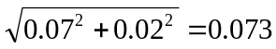

atan(0.02/0.07) = 15.9º + 90 = aspect of 105.9º

(ii) The 8 direction pour point model
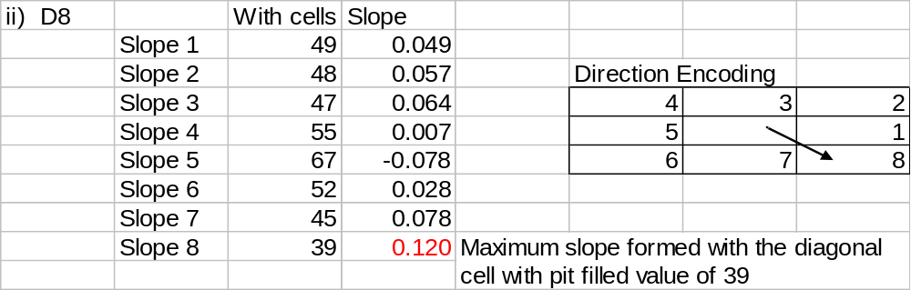
(This in an Excel Object so you can click on it to see formula's)

(iii) D∞
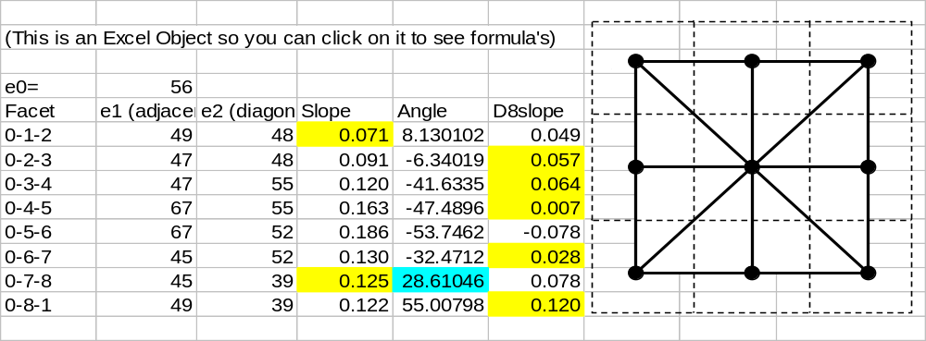
Slope is evaluated for each triangular facet using
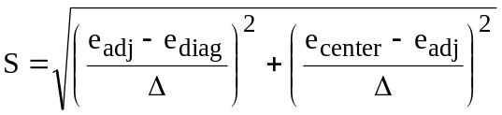
Angle evaluated using
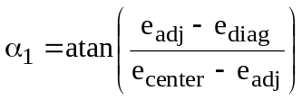
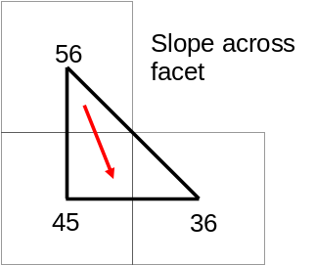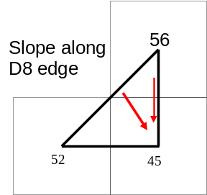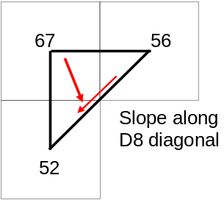The slope on a triangular facet is valid only if it is in the range 0 to 45°. When the angle is outside this range the slope down one of the D8 directions needs to be selected. The largest slope from all 8 triangular facets and the corresponding direction is selected as the D∞ slope and angle. The yellow highlight shows the slopes from which the largest is selected. In this case it is the slope value of 0.125 associated with the facet 0-7-8 and angle 28.6° which corresponds to 298.6° = 5.212 radians counter clockwise from east (blue highlight). The D∞ slope is therefore 0.125.
c) Determine the flow direction grid using the 8-direction pour point method (D8) and pit filled elevations (from part a). Indicate the flow direction by using an arrow in each cell on the grid below. Again do this only for the ungreyed center cells as the flow directions for edge cells can not be determined.

57 | 55 | 47 | 48 | 48 | 50 | 53
53 | 67 | 56 | 49 | 52 | 54 | 42
53 | 52 | 45 | 39 | 39 | 43 | 38
51 | 58 | 40 | 42 | 40 | 39 | 38
55 | 39 | 38 | 38 | 36 | 38 | 38
57 | 55 | 47 | 48 | 48 | 50 | 53
53 |  |  |  |  |  | 42
53 |  |  |  |  |  | 38
51 |  |  |  |  |  | 38
55 | 39 | 38 | 38 | 36 | 38 | 38

d) Determine the flow accumulation grid corresponding to the D8 flow directions. Label each cell with the number of upstream cells draining into it (ESRI convention), again only for the ungreyed center cells.

Flow accumulation grid, fill in values

 | 0 | 0 | 0 | 0 | 0
 | 0 | 1 | 4 | 6 | 0
 | 0 | 1 | 0 | 0 | 7

e). If the annual runoff (R) is given by the function R=0.51P-336, determine the annual runoff grid (mm/yr) given the annual rainfall grid below.

Annual Rainfall P (mm/yr)
900 | 980 | 1240 | 1260 | 1280 | 1290 | 1300
950 | 970 | 960 | 980 | 1050 | 1100 | 1180
940 | 945 | 950 | 958 | 985 | 1040 | 1100
860 | 890 | 920 | 940 | 970 | 990 | 1040
830 | 870 | 880 | 900 | 950 | 1000 | 1060

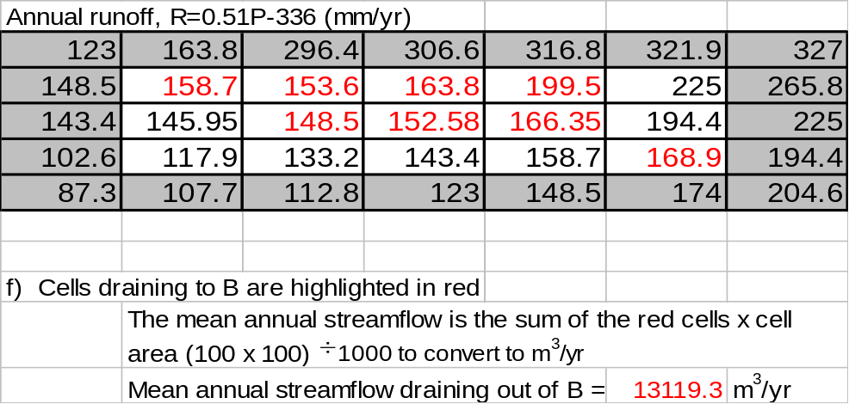

2. Checking with ArcGIS.
a) ArcGIS output from Fill
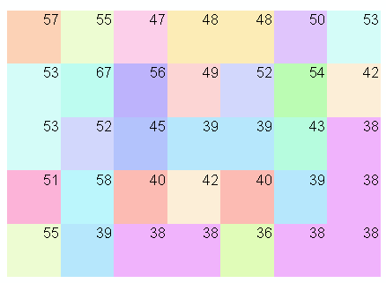
b) (i) Slope. Be sure to use the percent option
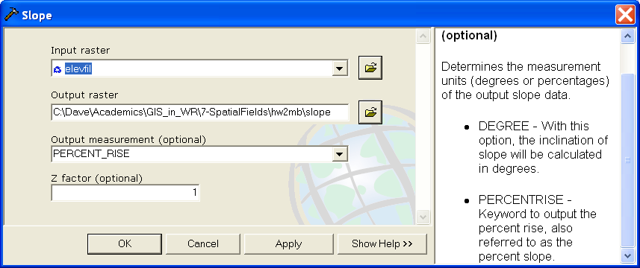

The value at cell A of 7.28 % corresponds to 0.073.
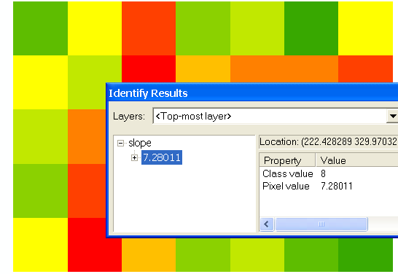

ArcGIS aspect value corresponds with hand calculations
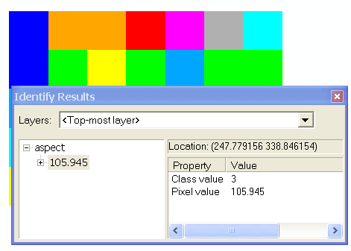

(ii) The Drops output from Flow direction gives the D8 slope in percentage. At Cell A this is 12% corresponding to 0.12.
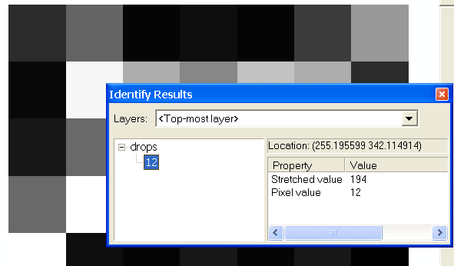
(iii) D∞ slope is evaluated using TauDEM

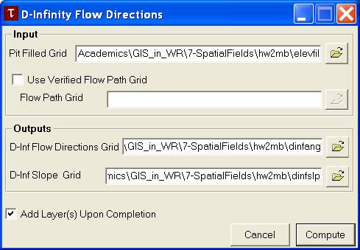

At cell A the result is 0.125. Note that slope is not evaluated for the edge cells because it can not be unambiguously defined.
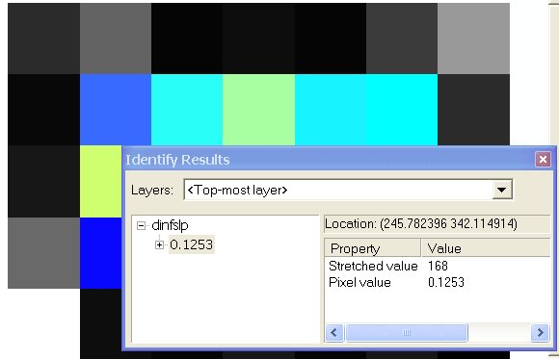

c) ArcGIS flow direction grid

Encoding
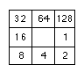
Notice how ArcGIS makes assumptions about flow directions along the edges, even though they are ambiguous. This will impact the flow accumulation comparisons.
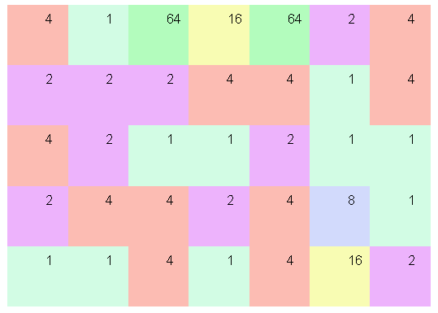

d) ArcGIS flow accumulation values. Note that these differ in certain places from the hand calculation due to accumulation of edge cells.
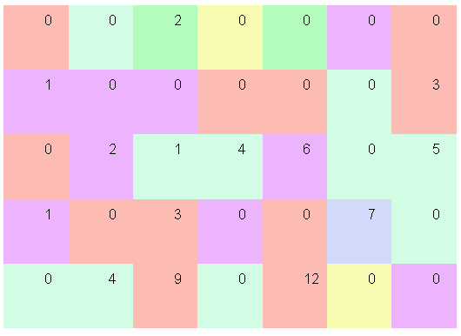

e) Annual Runoff. Note the truncation to integer is used because a limitation of weighted flow accumulation is that it requires the input weight grid to be integer valued.
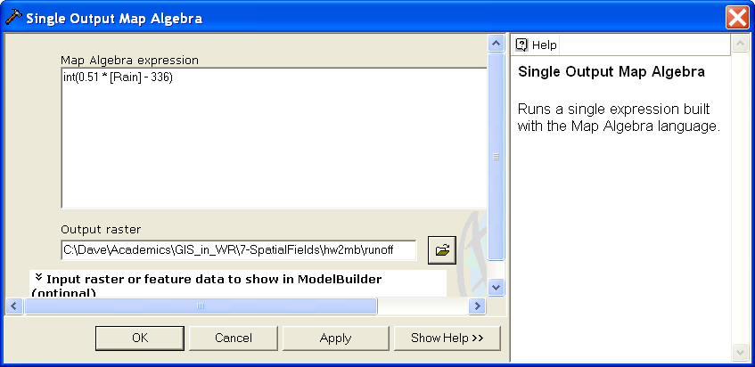

ArcGIS runoff calculation
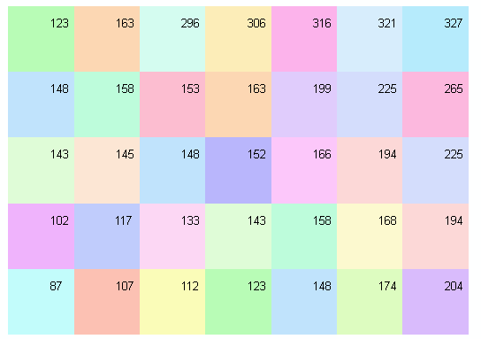

f) Weighted flow accumulation evaluation of discharge
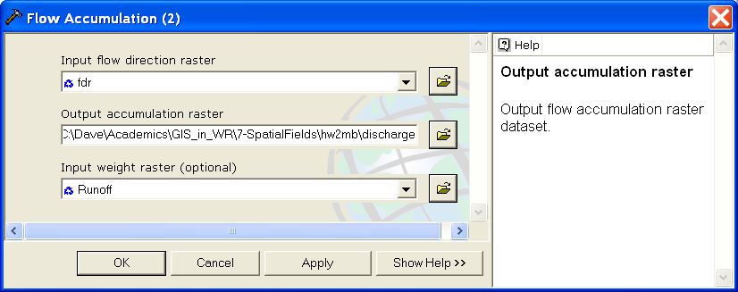

Discharge at outlet cell.
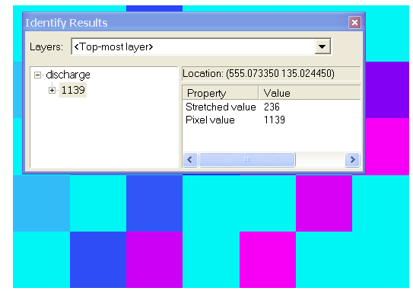
This does not include the cell value itself and is not converted to m³

(1139 + 168)*100*100/1000 = 13070 m³/yr. This corresponds to the 13119 calculated by hand given the integer truncation that has occurred in ArcGIS.

The model builder toolbox hw2.tbx contains a model Rainfall Runoff that implements the ArcGIS part of these calculations, except for the TauDEM Dinf function.


