Watershed Delineation and Precipitation Interpolation and Accumulation over Watersheds
GIS in Water Resources
Fall 2004

Goal
The goal of this exercise is to serve as an introduction to Spatial Analysis with ArcGIS and learn how to analyze precipitation data and compute watershed average precipitation data from a variety of data sources.

Overview of what is to be done
1. Use the results of Exercise 3 to delineate watersheds and subwatersheds for the USGS streamflow gages within San Marcos basin.
2. Use rain gage data from a set of rain gages surrounding the basin to develop an annual rainfall map for each of the years 2000 to 2003 by interpolation. Compare alternative interpolation methods.
3. Evaluate the rainfall each year over each subwatershed using zonal averaging.

Computer and Data Requirements
To carry out this exercise, you need to have a computer, which runs the ArcInfo version of ArcGIS. The data are provided in the accompanying zip file, SanMarcos.zip.

Data description:
SanMarcos.zip contains the results from the watershed and stream network delineation exercise 3 as well as a geodatabase with rainfall and USGS stream gage data. To start this exercise extract the entire contents of the zip file to a convenient location. For the purposes of this exercise I extracted the data to c:\dave\scratch.
The contents of the zip file are shown
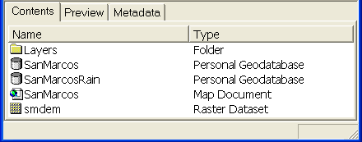
The results from exercise 3 comprise the following:
- SanMarcos.mxd. ArcMap document that displays the necessary layers.
- Smdem. Projected 100 m DEM grid developed in exercise 3.
- The "Layers" folder containing the ArcHydro grid output
- SanMarcos personal Geodatabase containing ArcHydro feature class output
Also included is the SanMarcosRain personal Geodatabase. This contains the following
- A table "AnnualRain" comprising annual rainfall data that has already been extracted from the NCDC website following the procedures described in "ncdcdata.doc".
- A featuredataset "BaseMapGeo" that contains (in geographic coordinates), the feature classes RainGage, GuadalupeRf1Streams and USGSStreamGages. This is the entire set of USGS Stream Gages for the country so may be useful for other purposes.

Watershed Processing
Open the ArcMap document SanMarcos.mxd extracted from the zip file. You may get the red exclamation marks indicating that the data can not be found. If this occurs Right click on one of the missing data layers and select Data→Set Data Source

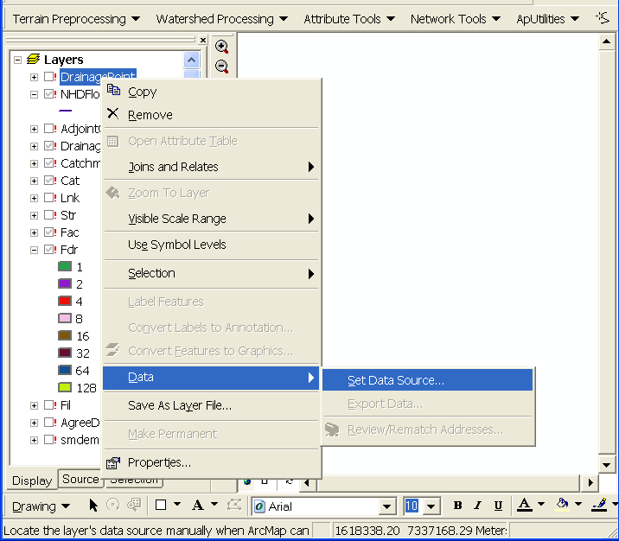

Browse to the appropriate data layer. You will have to do this a number of times, but should not have to do it for all layers as layers in the same workspace are automatically found when the first layer is located.

The steps in Terrain Preprocessing up to Drainage Point Processing have already been done following the procedure in Exercise 3. In general these steps need to be performed before the watershed delineation functions illustrated below on the next menu may be used.
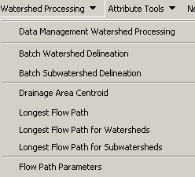

1. Batch Watershed Delineation
This function delineates the watershed upstream of each point in an input Batch Point feature class.

Because ArcMap has just been opened we need to Set the Target output locations properly. From The ApUtilities Menu Set Target Locations.
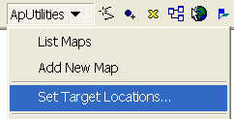

Click HydroConfig

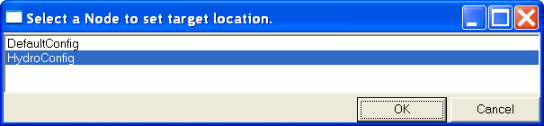

Adjust the target locations to point to the location where you unzipped the data.

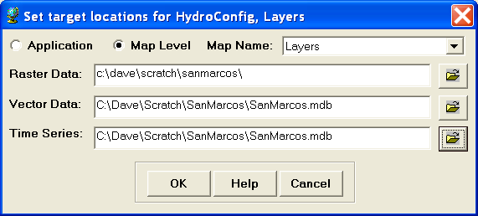
The Arc Hydro tools Batch Point Generation can be used to interactively create the Batch Point feature class. We will use this to locate the outlet of the watershed. Add GuadalupeRf1Streams from SanMarcosRain.mdb/BasemapGeo and SanMarcosSubbasin from SanMarcos.mdb/Layers to your map display. Adjust your display to zoom in near the outlet and show only the flow accumulation grid "fac", SanMarcosSubbasin and GuadalupeRf1Streams.
Click on the icon in the Arc Hydro Tools toolbar. Click on the outlet just upstream of the junction with the main Guadalupe river. Pick the grid cell where the SanMarcosSubbasin boundary crosses the Fac flow path.
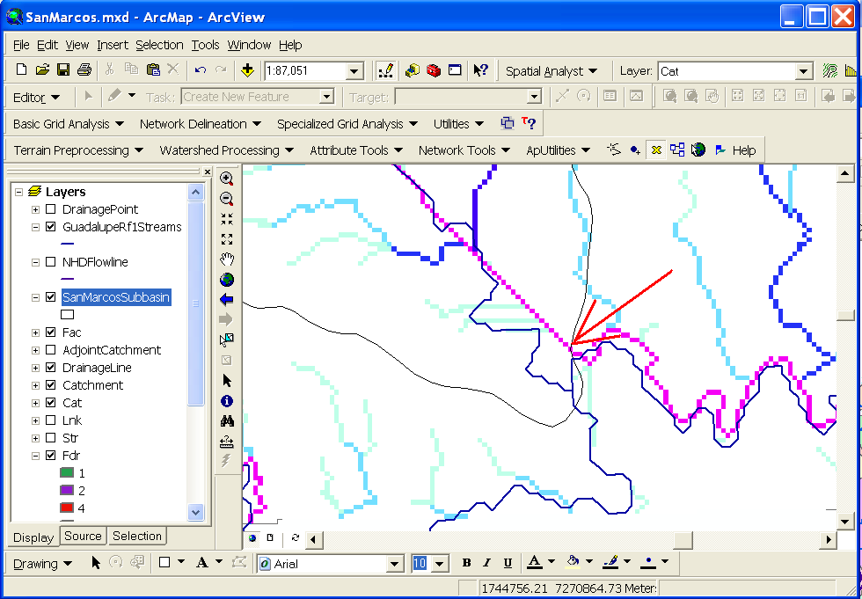

If you get an error it may be because your target locations were not set correctly so try set them again.

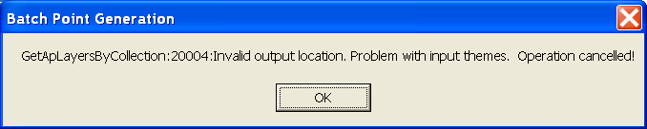

Once locations are set correctly the following form is displayed:
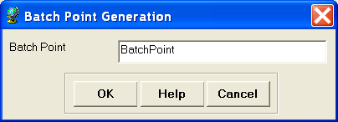

Confirm that the name of the batch point feature class is “BatchPoint”. A point is then created at the location of mouse click, and the following form is displayed:

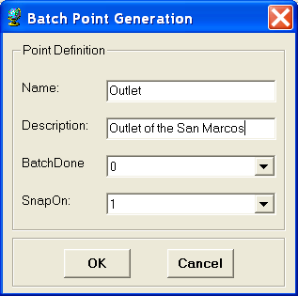
Fill in the fields Name and Description. Both are string fields. The BatchDone and SnapOn options can be used to turn on (select 1) or off (select 0) the batch processing and stream snapping for that point. Select the options shown above. The input information is saved in the attribute table of the BatchPoint feature class. Click OK. You should see that a single point feature class has been created comprising the outlet point where you clicked.

When snapping is turned on, if your point is sufficiently near to a drainage line (within around 5 grid cells) then the point will be snapped (i.e. moved) to a nearby drainage line before delineation of the upstream watershed, otherwise the local watershed draining to the point will be delineated. The following figure indicates the behavior you may expect from the delineation of watersheds upstream of input Batch Points.
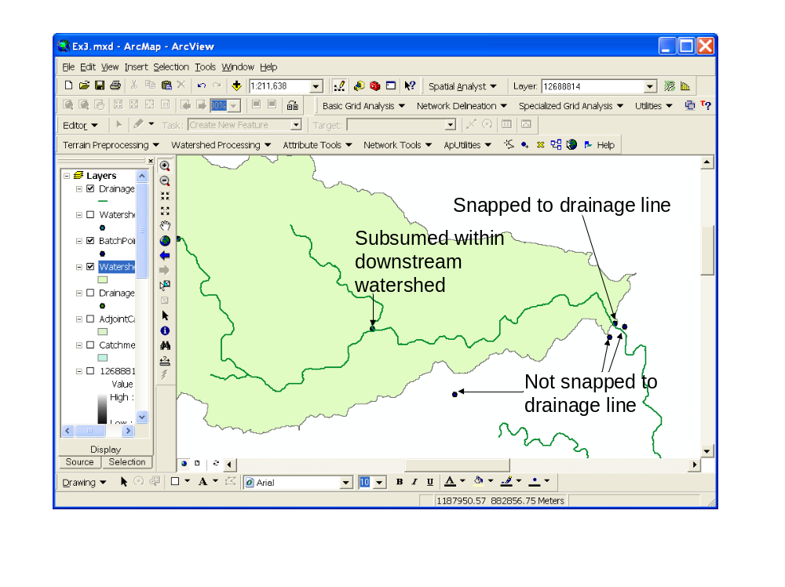

To perform a batch watershed delineation
Select Watershed Processing | Batch Watershed Delineation.
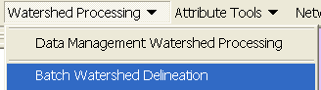

Confirm that “Fdr” is the input to Flow Direction Grid, “Str” to Stream Grid, “Catchment” to Catchment, “AdjointCatchment” to AdjointCatchment, and “BatchPoint” to “Batch Point”. For output, the Watershed Point is “WatershedPoint”, and Watershed is “Watershed”. “WatershedPoint” and “Watershed” are default names that can be overwritten.

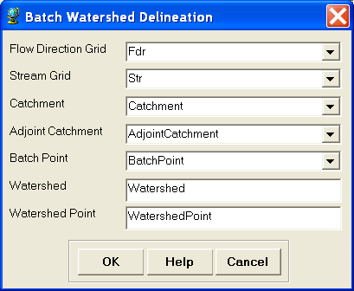
Press OK. The following message box appears on the screen, indicating that 1 point has been processed.

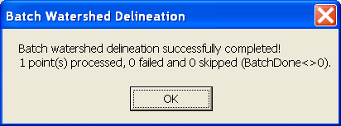

The delineated watersheds for the selected point should correspond closely to the outline of the San Marcos Watershed..

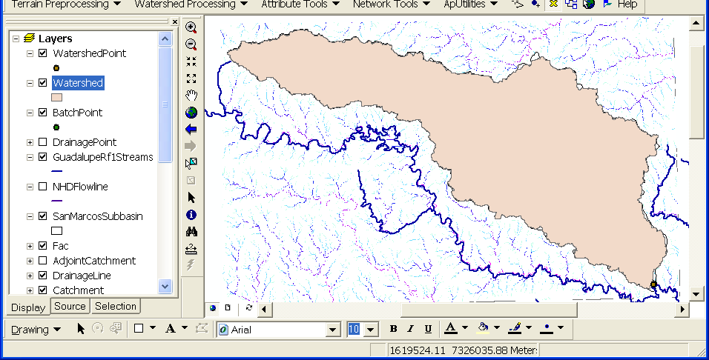

To be turned in: Make a layout showing the delineated watershed for your selected outlet. Report the Drainage Area of the watershed you delineated in km².

Delineating Watersheds from USGS gaging stations:

Add the USGSStreamGages feature class from the BasemapGeo feature dataset within the SanMarcosRain.mdb geodatabase. Click OK to the warning about the data being in a different projection. This is actually a "good" warning. It means that ArcGIS knows about the difference in projections and will project on the fly. These are the locations of all USGS stream gages (as of a certain date). We will use a Query to identify only those gages within the San Marcos.

Click Selection→Select by Location.

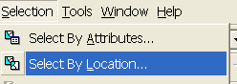

Adjust the dialog to select features from USGSStreamGages that intersect the features in the SanMarcosSubbasin.

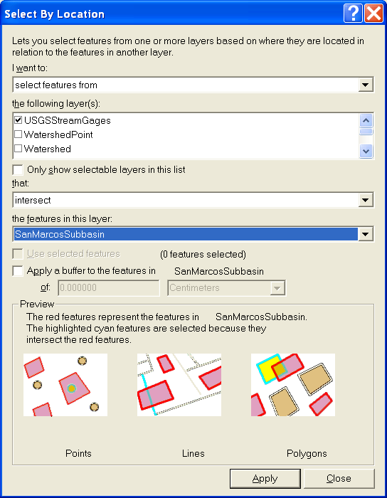
Click Apply and Close. The 9 stream gages with the San Marcos should be selected. Right click on USGSStreamGages layer, and export the selected data to SanMarcos.mdb/Layers as a feature class named SanMarcosStreamGages. By saving this layer within the "Layers" feature dataset the system will do on the fly projection to the same spatial reference as the target feature dataset. Click OK to add the points to ArcMap. Open the attribute table associated with SanMarcosStreamGages. Locate the record associated with San Marcos River Spring Flow at San Marcos. This record needs to be deleted. This gage is physically located at exactly the same location as the San Marcos R At San Marcos. This causes problems in some of the future processing. Select this record by clicking in the margin on the left to highlight it. Use the Editor toolbar to start editing. Push the Delete key to delete this record. Stop editing and Save edits.

To use these gages as watershed outlets these locations need to be appended to the Batchpoint feature class.

Open the Append tool.
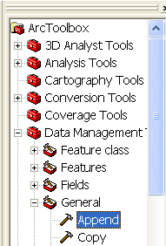

Set the input to SanMarcosStreamGages and Set the Output to BatchPoint. Click OK.

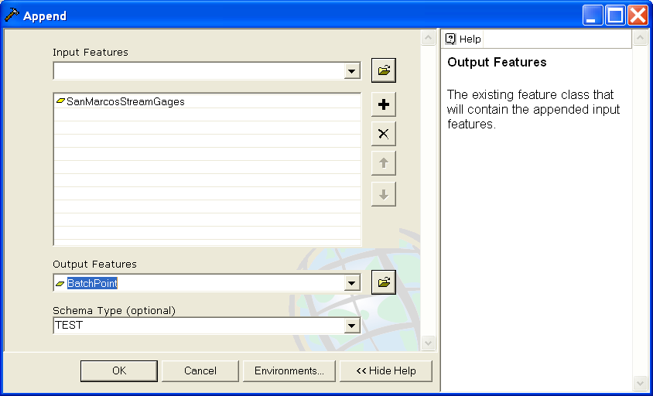

Open the BatchPoint Attribute table.

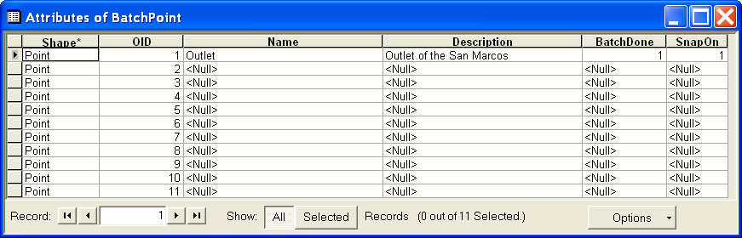

Notice that the 10 points from the SanMarcosStreamGages feature class have been appended to the outlet already there. To use these within Watershed Delineation we need to set the BatchDone and SnapOn fields. Right click on the BatchDone header and select Calculate Values.

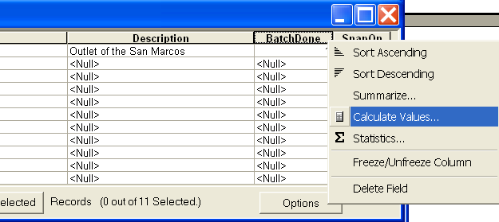

Click Yes to the field calculator warning about the calculations not being reversible.

Enter 0 in the BatchDone= field and click OK.
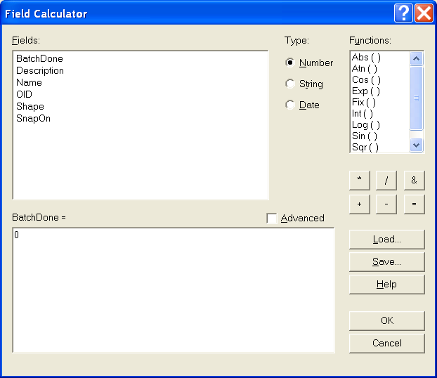

Notice that all the BatchDone values are set to 0. Similarly set SnapOn equal to 1. Use the Editor to set BatchDone for the Outlet to 1, because the watershed for this outlet has already been delineated and does not need repeating.

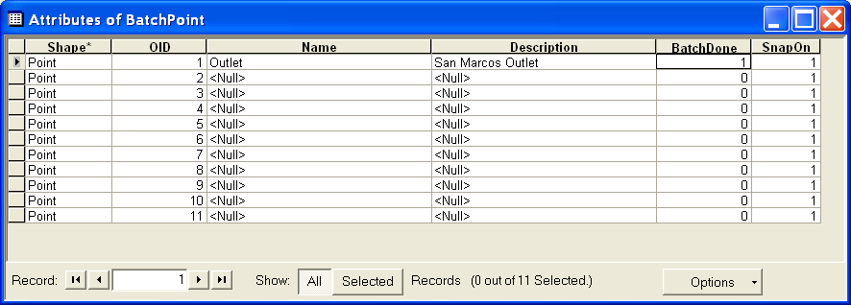

Close the attribute table and repeat the Watershed Processing→Batch Watershed Delineation function. The Watersheds draining to each stream gage should be delineated.
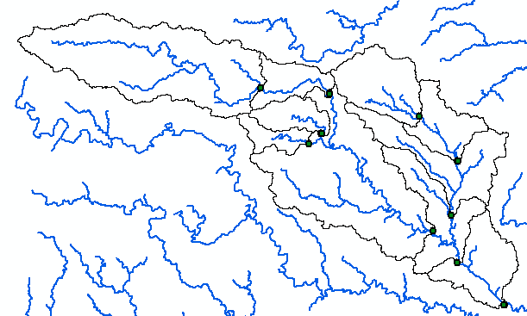

The attributes, such as names and USGS Station Number are not yet associated with the delineated watersheds. To remedy this we will use a Join based on spatial location. Right click on WatershedPoint/Joins and relates/Join

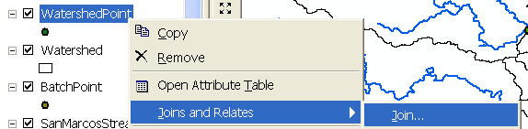

In the Join Data dialog specify Join data from another layer based on spatial location. Specify the layer to join to this layer as SanMarcosStreamGages. Under 2 specify each point given all the attributes in the layer closest to it. Specify the output feature class as SanMarcos.mdb\Layers\WatershedPointsWithStreamGages.

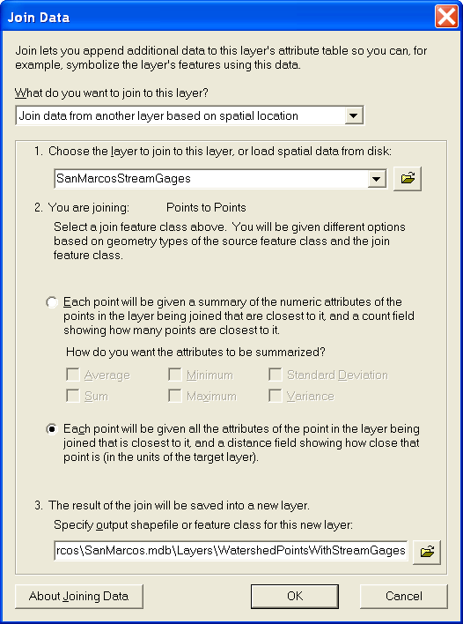

The attribute table of WatershedPointsWithStreamGages now includes all the USGS Stream Gaging station data. This includes a field DA_mi2 which I interpret to be drainage area in square miles. Lets compare these to the drainage area of the delineated watersheds.

Open the attribute table for the "Watershed" feature class. Notice that it contains a field "HydroID". This is a unique identifier associated with each Watershed. The attribute table of "WatershedPointsWithStreamGages" contains fields "HydroID" and "DrainID". HydroID is again unique (i.e. different from the HydroID of Watersheds and all other objects) because Points are separate objects from Watersheds. The DrainID field gives the relationship between these tables with "DrainID" in WatershedPoints giving the HydroID of the corresponding Watershed. We can therefore join the Watersheds attribute table onto the WatershedPoints table to associate watershed attributes with their outlet points.

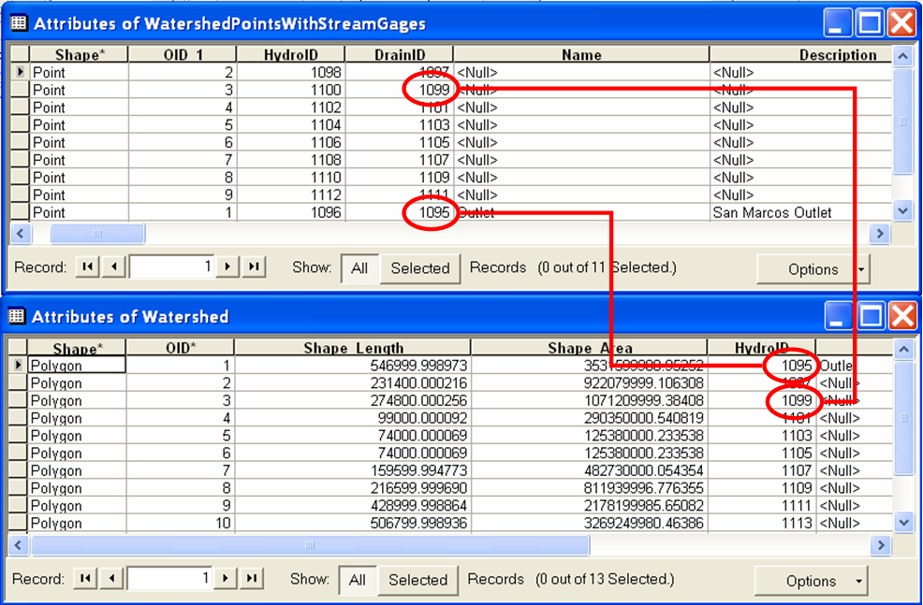

Right click on WatershedPointsWithStreamGages and select Joins and Relates/Join. Select to Join attributes from a table and select "DrainID" as the join field in this layer (WatershedPointsWithStreamGages). Select the "Watershed" table and HydroID field to join. Click OK.
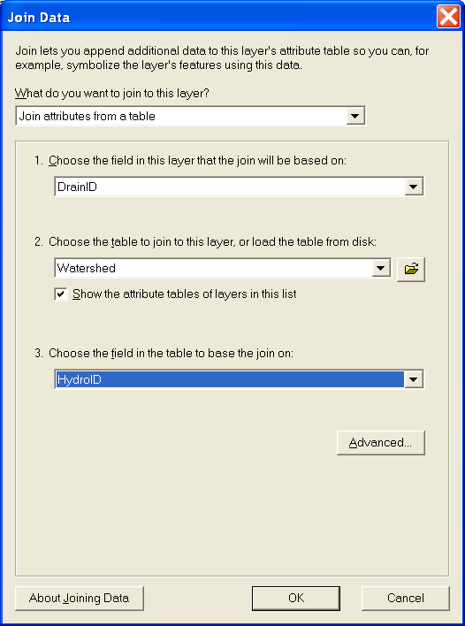

Click No to create index (indices are only really beneficial for large tables). Open the table attribute table for WatershedPointsWithStreamGages which now has watershed attributes joined to it. Click Options→Export to export the data into a DBF table.

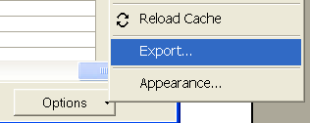

Open the DBF table that you obtain in Excel and use Excel to tidy it up and produce a presentation quality table that gives for each outlet point the following information:
Name, USGS gage number, Watershed point HydroID, Watershed HydroID, Drainage area from ArcGIS (converted km²), Drainage area from the USGS (converted to km²). Use Excel to plot the USGS watershed area versus ArcGIS watershed area.

To be turned in: Make a layout showing the delineated watershed for each USGS Gauging Station. Label each watershed outlet with its contributing Drainage Area obtained from the Watershed Feature class. Prepare a table using Excel giving Name, USGS gage number, Watershed point HydroID, Watershed HydroID, Drainage area from ArcGIS (converted km²), Drainage area from the USGS (converted to km²). Prepare a graph comparing USGS watershed area to ArcGIS watershed area. Comment on reasons for any differences or discrepancies you find.

2. Interactive Point Delineation

An alternative to delineate watersheds when you do not want to use the batch mode (process a group of points simultaneously) to generate the watershed for a single point of interest is the Point Delineation tool .
Click on the Point Delineation icon in the ArcHydro toolbar to activate the tool. Zoom in to the network and click the mouse (along the drainage line) to create your point of interest.
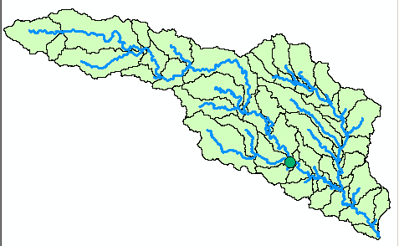
Click “Yes” if the following message is displayed.

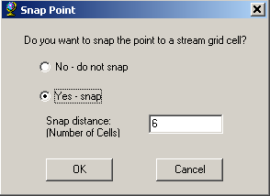

Press OK to snap the point to a stream grid cell (this form will not be presented if the point is already on the stream).
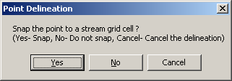
After the delineation is complete, fill in the name and comment as shown below in the form.

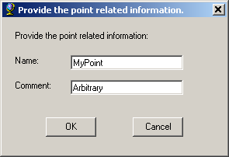

After all the information is fed, a watershed will be added to the “Watershed” feature class, and the point you created is added to the “WatershedPoint” feature class.

To show only the new watershed from the watershed feature class, use symbology→Unique Value→ use “Name” for the value field, and use Hollow symbols for other fields with “0” value for border width.

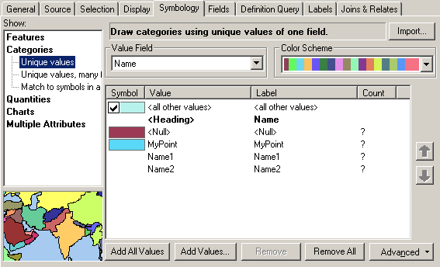

The delineated watershed for the selected point is shown below.
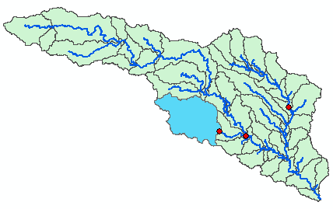

To be turned in: Make a layout showing the delineated watershed for your selected point including the DrainageLine and the Catchments

3. Batch Subwatershed Delineation
This function delineates subwatersheds for all the points in a selected Point Feature Class.
Input to the batch subwatershed delineation function is a point feature class with point locations of interest. In this context a watershed, such as was delineated above is the entire area upstream of a point, while a subwatershed is the area that drains directly to a point of interest excluding any area that is part of another subwatershed. Subwatersheds delineated from a set of points are therefore by definition non overlapping because the watershed draining to a point that is within another watershed is excluded from the subwatershed of the downstream point. On the other hand, watersheds may overlap. We will delineate subwatersheds from the same USGS stream gages plus outlet point as used for Watershed delineation.

Open the BatchPoint attribute table and use the field calculator to set BatchDone = 0. Select Watershed Processing | Batch Subwatershed Delineation.
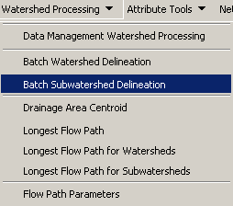
Confirm that the input to the Flow Direction Grid is “Fdr”, and the input to Stream Grid is “Str”. The output Subwatershed is named by default “Subwatershed”, and the output Subwatershed Point is named by default “SubwatershedPoint”.

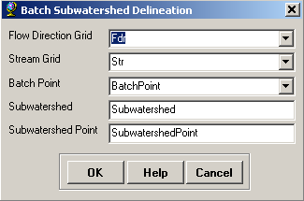
Press OK. The points are added to SubwatershedPoint, and the subwatersheds are added to Subwatershed. The delineated subwatersheds are shown below.

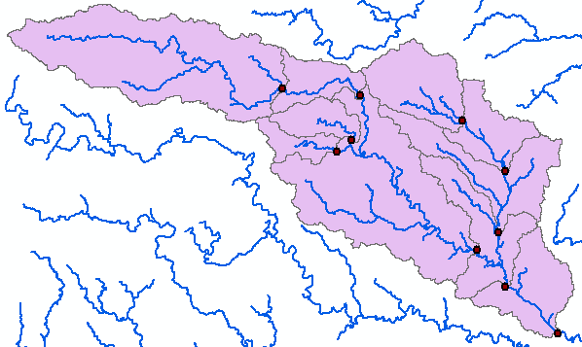

To be turned in: Make a layout showing the delineated subwatersheds the San Marcos stream gages and basin outlet point. Include the DrainageLine and the Catchments feature classes.

4. Flow Path Tracing
Click on the Flow Path Tracing icon in the ArcHydro toolbar to activate the tool. If asked, confirm that the input of the Flow Direction Grid is “Fdr”.

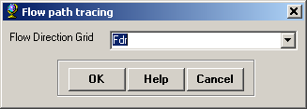

Click your mouse at any point to determine the flow path. The flow path defines the path of flow from the selected point to the outlet of the catchment following the steepest descent. If you select a point along the stream network, the flow path will follow the exact path of the stream.

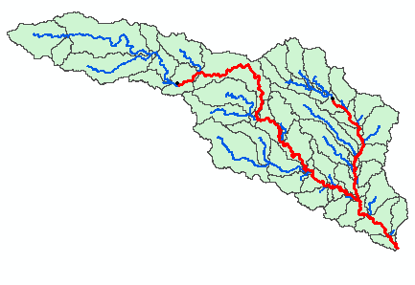

To be turned in: Make a layout showing the flow path for your selected point including the DrainageLine and the Catchments.

5. Rainfall Interpolation
Add the feature class RainGage from SanMarcosRain.mdb/BaseMapGeo. At the "good" warning that this layer has a different projection click OK. This warning serves as a useful reminder. Since we will be doing quite a bit of work with the RainGage data it is useful to have it in the same projection as the watersheds. Lets save it in the SanMarcos.mdb/layers feature dataset. This will change the spatial reference (projection) on the fly. Right click on RainGage and select Data→Export Data. Browse to save the feature class in SanMarcos.mdb/layers with the name RainGage.

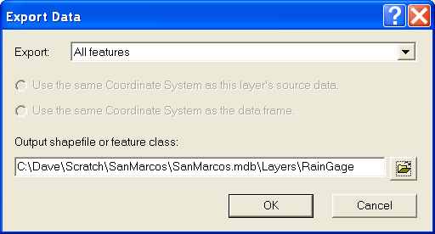

Click Yes to add the layer to the map and then remove the older "RainGage" layer so we do not get confused.

Add the table AnnualRain from SanMarcosRain.mdb.

The RainGage feature class and AnnualRain table is data that has been prepared for you from data downloaded from NCDC using the procedure described in "ncdcdata.doc". The RainGage feature class contains static spatial data associated with the rain gages within counties that intersect with the San Marcos basin. The AnnualRain table contains records giving short time series of annual rainfall from 2000-2003.

Lets explore the data a bit. Open the attribute table associated with the RainGage feature class. Notice that it contains among other fields a field named COOPID. This is the unique identifier associated with this data.

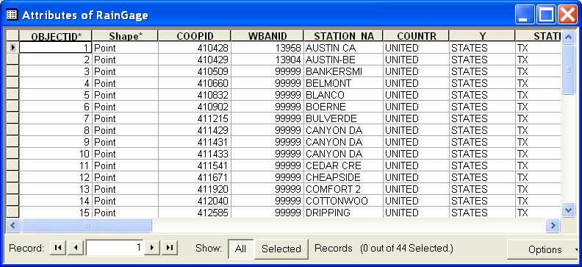

Open the AnnualRain table. Notice that it contains fields COOPID, Year, ANNUAL and AnnRainInch. COOPID is the unique station identifier (from the cooperative network) that is associated with the location data in feature class RainGage. AnnRainInch is the annual rainfall in inches.

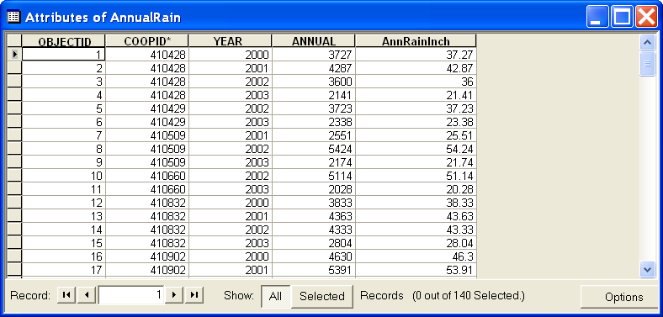

There is a one to many relationship between these tables. One record in RainGage is associated with many records (one for each year in AnnualRain). This relationship can be instantiated in ArcGIS through a relationship. Once this has been created it facilitates analysis of the spatial variability of annual rainfall.

Right click on RainGage and select Joins and Relates→Relate.

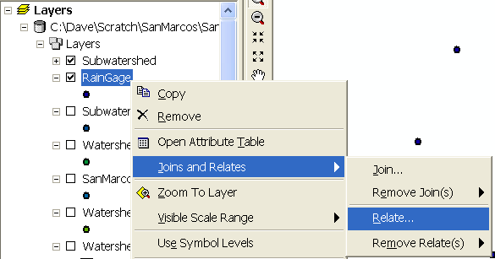

Select the field that the relate will be based on as COOPID. Select the table to relate to as AnnualRain. Choose the field in the related table to be COOPID and give the relationship a name. Click OK.

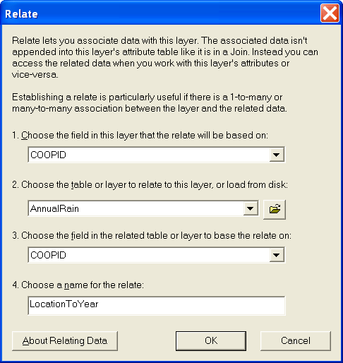

Now use the identify tool to examine attributes associated with the raingages. At the first level of the identify one gets the attributes in the RainGage feature class.

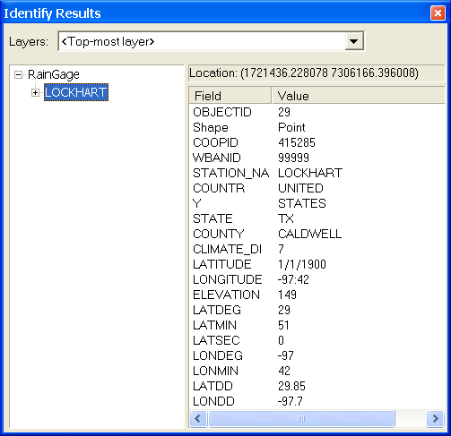

It is possible to drill down through relationships by expanding the table of contents tree on the left by clicking on the + to see attributes of AnnualRain at each station.

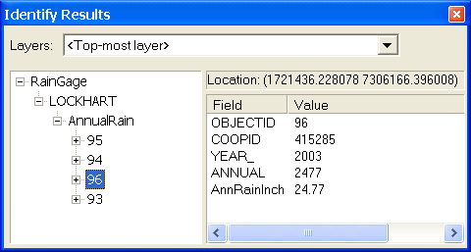

To produce annual rainfall surfaces the first step in the analysis is to identify the records for each year to prepare an annual rainfall feature class for each year. This will then be used to interpolate an annual rainfall surface for each year.

Open the AnnualRain table. Click Options→Select by attributes. Double click year. Click equals. Click get unique values. Double click 2000. You should have a query that looks as follows:
[This exercise is illustrated using the year 2000, however you will need to hand in a layout for year 2003, so you may wish to alter 2000 to 2003 as you work through this to save repeating it for yourself.]

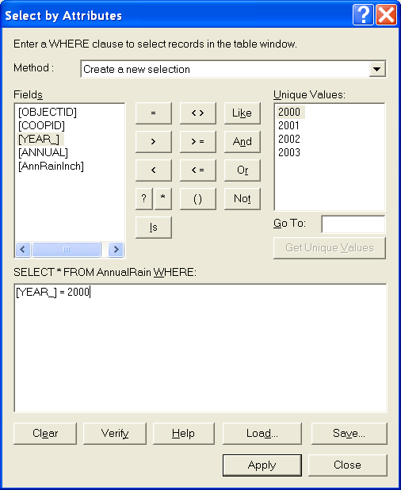

Click Apply. The AnnualRain table should show 32 of 140 records from 2000 selected.

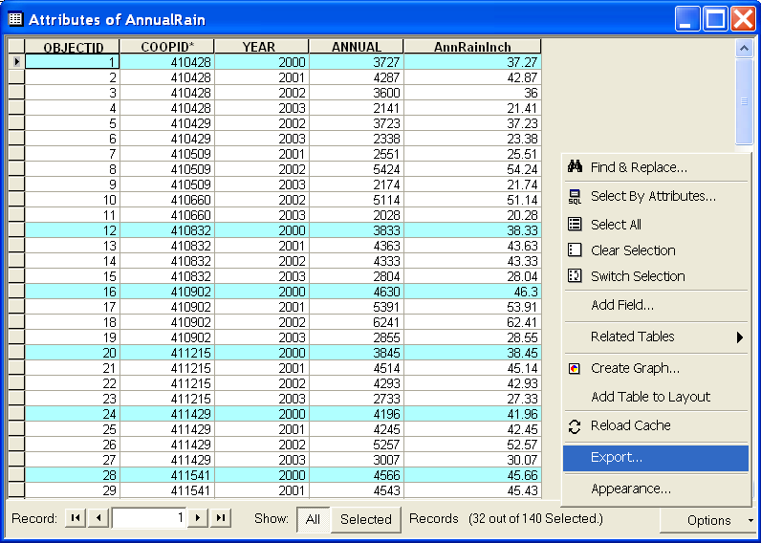

Click Options→Export. Save the Selected records as a table within SanMarcos.mdb named "AnnualR2000".

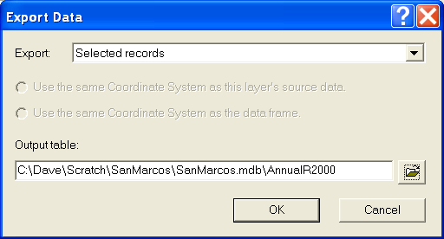

Next, join this table to the RainGage feature class. Right click on RainGage→Joins and Relates→Join. Specify the Join data as follows to Join using COOPID as the key field for the join.

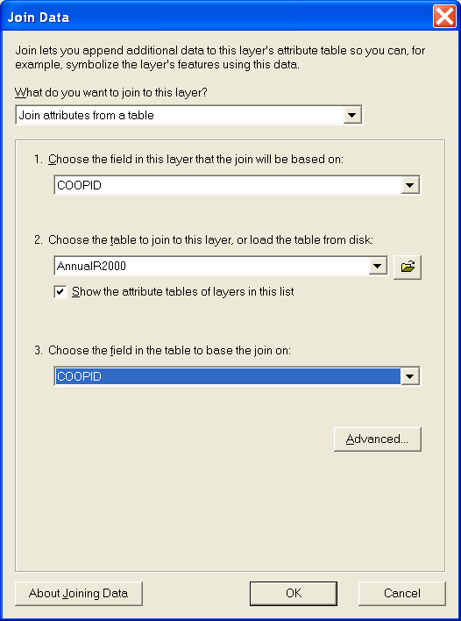

Open the RainGage table and note that it now shows the joined attributes from AnnualR2000. The field AnnualR2000.AnnRainInch is what we are interested in. <Null>'s indicate missing data.
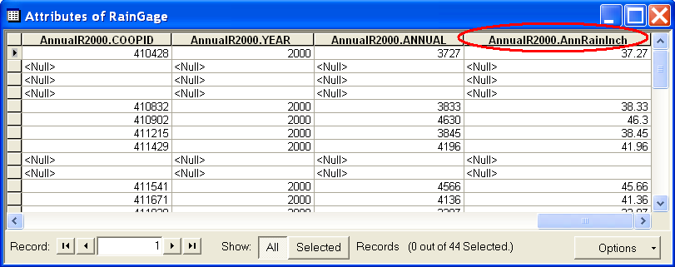

Eliminate the missing data by right clicking Options→Select By Attributes

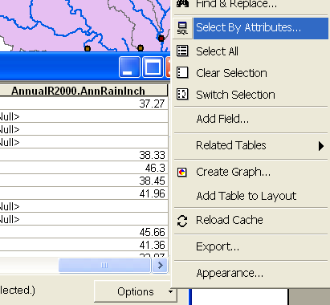

Invoke the query "AnnualR2000.AnnRainInch >=0"

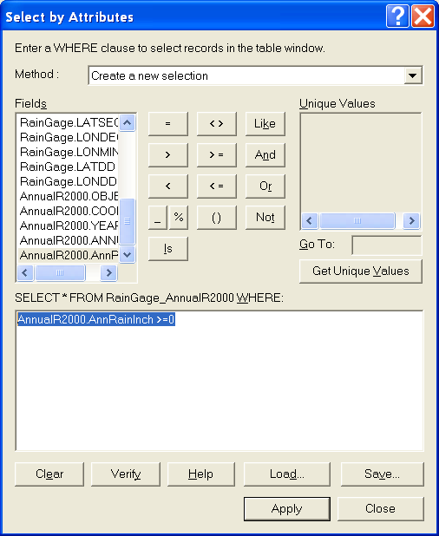

With these records selected right click on RainGage→Data→Export data to save the selected records as a feature class SanMarcos.mdb\Layers\RainPoint2000.

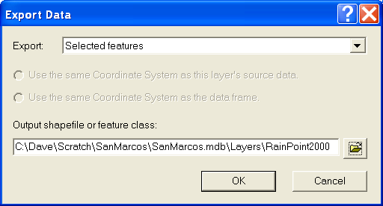

A similar procedure could be used to create tables for each of the years 2001 – 2003, however this is repetitive, so will be done using model builder later. If you will be repeating this work for another year it is convenient to remove the existing joins before joining a new table, or else the combination table gets rather big and difficult to navigate.

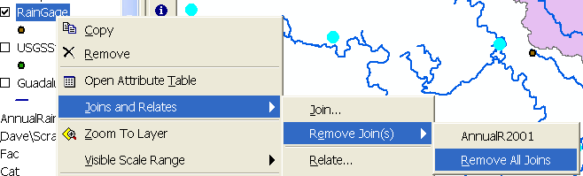

Use the Properties→Labels tab to label the RainGage features with the Annual Rainfall in Inches field.

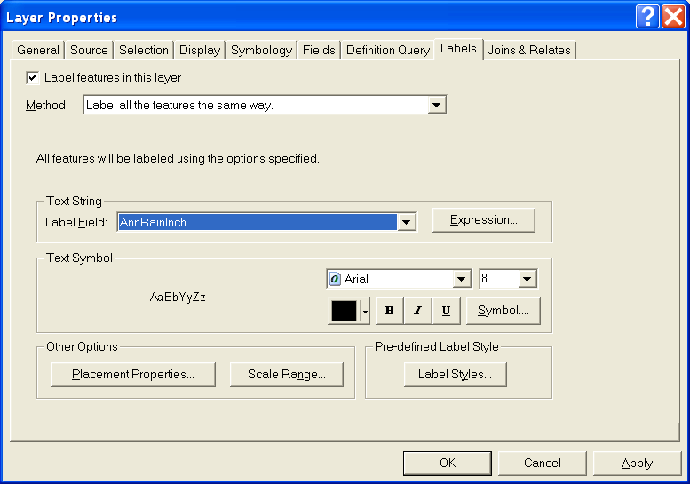

Click on Expression and enter the expression " round([AnnRainInch],1)" to round the data to one decimal place in the labels.
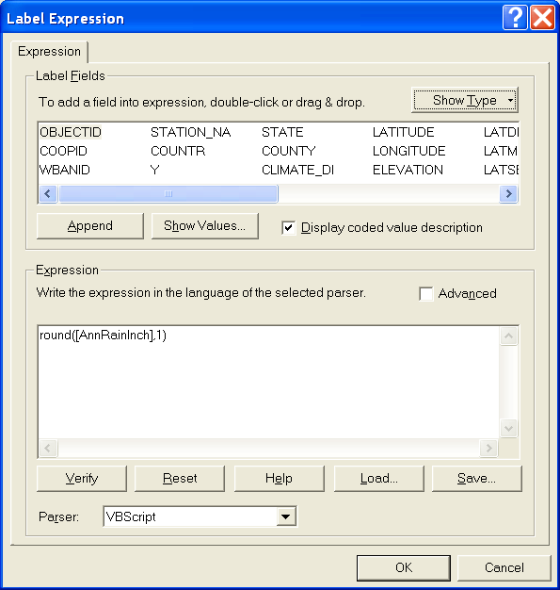

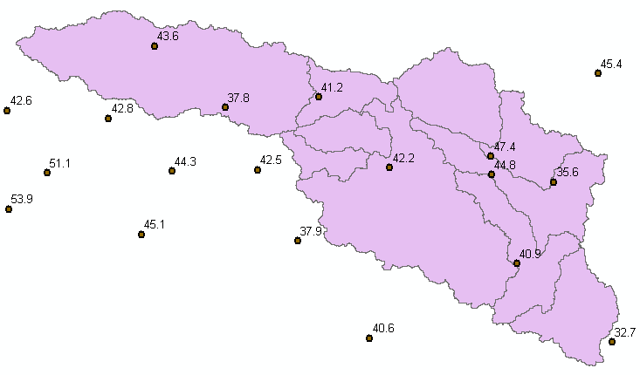

To be turned in: Make a layout showing the annual rainfall at each rain gage for the year 2003. Indicate the number of gages with non null rainfall data in this dataset in the year 2003.

The next step is to convert these point rainfall patterns to spatial rainfall fields represented as a raster using interpolation. ArcGIS Spatial Analyst provides three Interpolate to Raster methods, Inverse Distance Weighted, Spline, Kriging. There are choices and parameters within each of these.

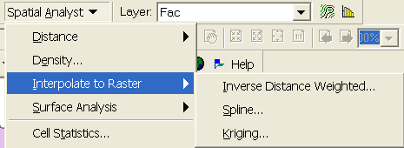

Feel free to try any of these. Here we illustrate each with the year 2000 data.

Select Spatial Analyst→Interpolate to Raster→Inverse Distance Weighted.

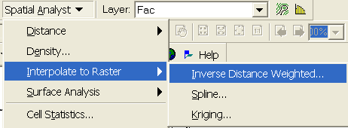

Set "RainPoint2000 as the Input points. Set AnnRainInch as the Z value field. Name the Output Raster Rain2000idw. Leave the remainder of the settings at their defaults (or experiment with them if you like).
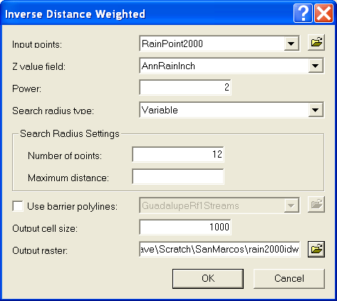

Following is the result.

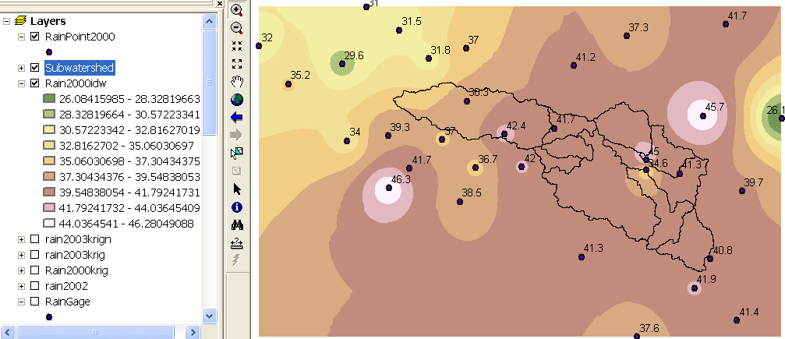

Notice how inverse distance weighting results in a pattern with concentric circles around the gage points.

Select Spatial Analyst→Interpolate to Raster→Spline.
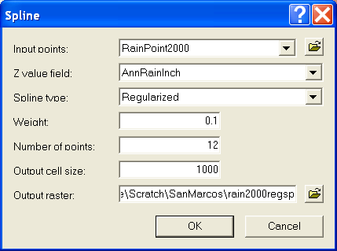

The result from a Regularizes Spline is

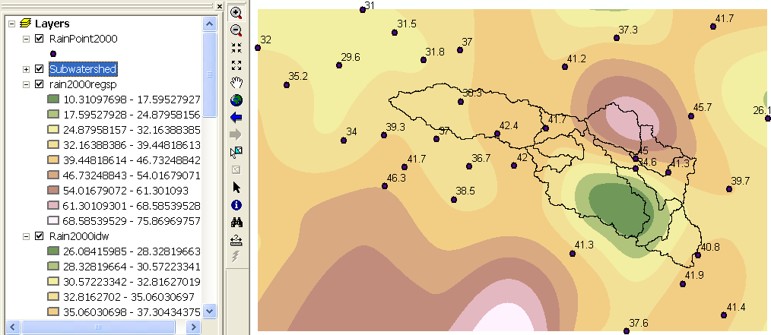

Select Spatial Analyst→Interpolate to Raster→Spline. Choose Tension.
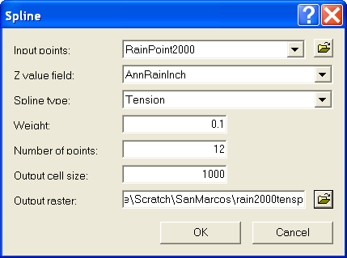

The result from a Tension Spline is

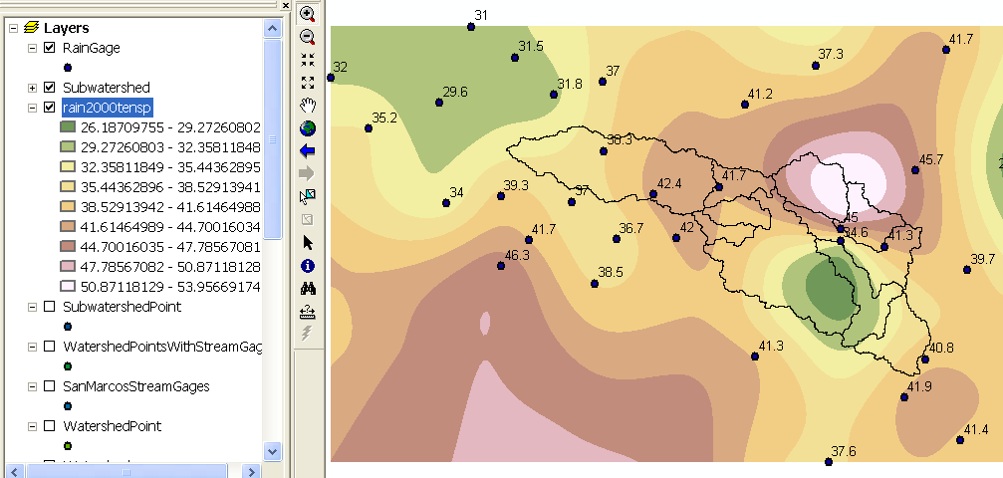

Select Spatial Analyst→Interpolate to Raster→Kriging.

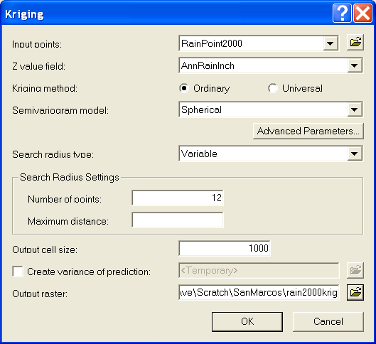

The result from Kriging is

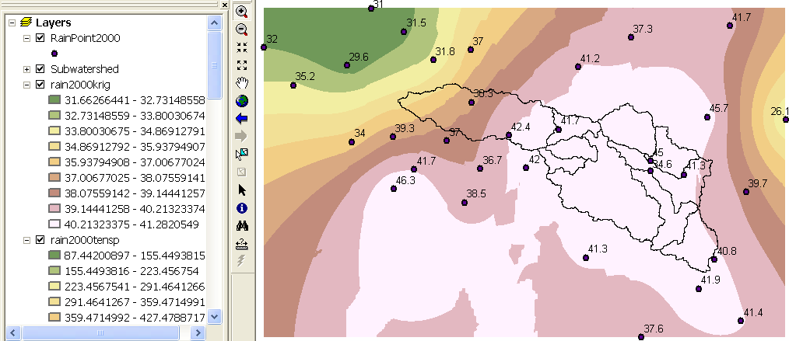

Recognizing that it is repetitive to run these interpolations by hand some model builder tools have been constructed to do this for you. These are in the ex4.tbx model toolbox that may be downloaded from the website and saved in the folder where you are working.

Open ArcToolbox. Right click in the white space somewhere and select Add Toolbox
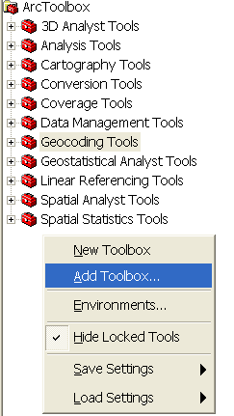

Browse to the toolbox Ex4.tbx and click open. You should obtain the following tools on your toolbox display.
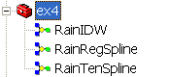

Double click on the tool RainIDW. In the dialog that appears adjust the necessary parameters to specify inputs and control the names of outputs. The first box is the AnnualRain time series table that is input. The second box is the query to indicate the year that is to be selected. The third input is the RainGage feature class giving raingage locations and the fourth box is the output grid. Once these are set click OK.

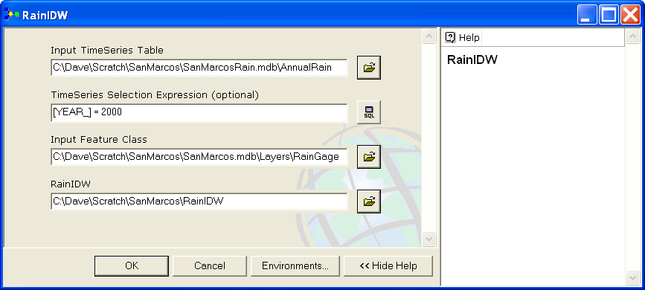

A map of Inverse distance weighted interpolated rainfall is added to your map.

Right click on the tool RainIDW and click Edit. This takes you to the model builder display that shows the model. You can see that it has implemented a sequence similar to what was done above.

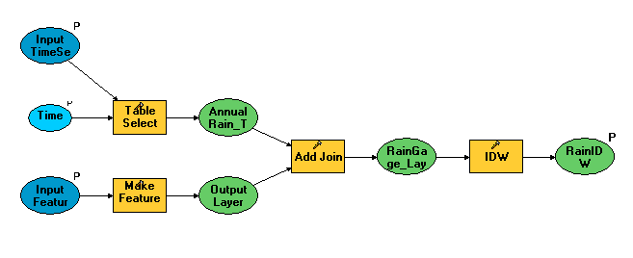

The tools RainRegSpline and RainTenSpline are similar but implement interpolation using splines.

To be turned in: Make a layout showing the annual rainfall field for two years of your choice using a different interpolation method for each. Include subwatershed outlines and rain gages in your layout. Label the raingages with the annual rainfall amount.

Once we have a rainfall field, the field values can be zonally averaged over Watersheds and Subwatersheds to obtain the area average precipitation that is a common hydrologic model input. This will be illustrated using the 2000 tension spline interpolated rainfall surface.

Select Spatial Analyst→Zonal Statistics. Adjust the inputs to use Watershed as the Zone dataset with HydroID as the zone field. Use Rain2000tensp as the value raster and specify Watershed2000ZoneStat.dbf as the output table.

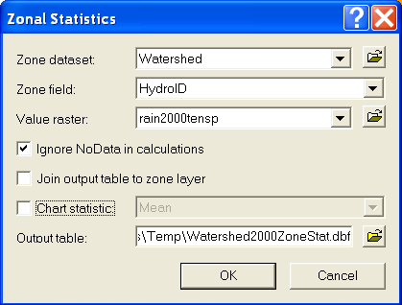

Join the Watershed2000ZoneStat.dbf table to the WatershedPointswithStreamGages table. Recall this is the table with attributes of both the watersheds and stream gages and now we are adding to it the annual rainfall. Use the WatershedPointsWithStreamGages.DrainID as the key field to join to HydroID from the Watershed2000ZoneStat table, recalling that DrainID of watershed points corresponds to HydroID of Watersheds.

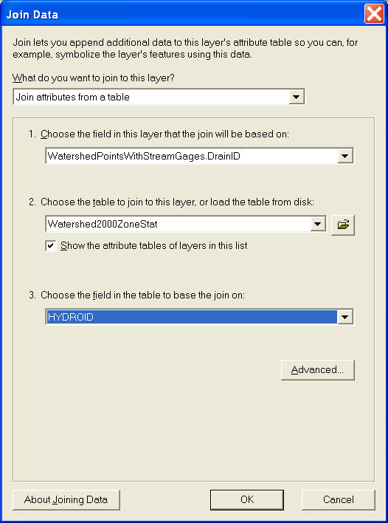

Export the resulting joined table to a DBF table. This table contains fields that include STATION_NO, the USGS station number, SNAME, the USGS station name, Shape Area and ZoneStat mean. Open the table using Excel and then tidy it up deleting superfluous information. Repeat this process for the years 2001 to 2004 for an interpolation method of your choice.

To turn in. A neat Excel table that gives for each watershed the following fields: Name, Station number, Drainage Area, Annual rainfall for each of the years 2000-2003. Indicate the interpolation method that you used.

Summary of Items to turn in
- Make a layout showing the delineated watershed for your selected outlet. Report the Drainage Area of the watershed you delineated in km².
- Make a layout showing the delineated watershed for each USGS Gauging Station. Label each watershed with its Drainage Area obtained from the Watershed Feature class. A table prepared using Excel giving Name, USGS gage number, Watershed point HydroID, Watershed HydroID, Drainage area from ArcGIS (converted km²), Drainage area from the USGS (converted to km²). A graph comparing USGS watershed area to ArcGIS watershed area. Comment on reasons for any differences or discrepancies you find.
- Make a layout showing the delineated watersheds for your selected points including the DrainageLine and the Catchments.
- Make a layout showing the delineated subwatersheds the San Marcos stream gages and basin outlet point. Include the DrainageLine and the Catchments feature classes.
- Make a layout showing the flow path for your selected point including the DrainageLine and the Catchments.
- Make a layout showing the annual rainfall at each rain gage for the year 2003. Indicate the number of gages with non null rainfall data in this dataset in the year 2003.
- Make a layout showing the annual rainfall field for two years of your choice using a different interpolation method for each. Include subwatershed outlines and rain gages in your layout. Label the raingages with the annual rainfall amount.
- A neat Excel table that gives for each watershed the following fields: Name, Station number, Drainage Area, Annual rainfall for each of the years 2000-2003. Indicate the interpolation method that you used.

