Exercise 4. Watershed Delineation from Digital Elevation Models

GIS in Water Resources
Fall 2003
Prepared by David G. Tarboton, Utah State University
David Maidment and Oscar Robayo, University of Texas at Austin

Part A. ArcHydro

Purpose
The purpose of this exercise is to illustrate, step-by-step, how to use the major functionality available in the Arc Hydro tools for Raster Analysis. This is a hands-on document focusing on how, not why.
In this exercise, the user will perform drainage analysis on a terrain model for Reynolds Creek. The Arc Hydro tools are used to derive several data sets that collectively describe the drainage patterns of the catchment. Raster analysis is performed to generate data on flow direction, flow accumulation, stream definition, stream segmentation, and watershed delineation. These data are then used to develop a vector representation of catchments and drainage lines from selected points. The utility of the Arc Hydro tools is demonstrated by applying them to develop attributes that can be useful in hydrologic modeling. To accomplish these objectives, the user is exposed to important features and functionality of the Arc Hydro tools, both in the raster and the vector environments.

Computer and Data Requirements
To carry out this exercise, you need to have a computer, which runs ArcInfo version of ArcGIS with the Spatial Analyst extension. You also need the Arc Hydro software. The data and software for this exercise are included in the accompanying zip file, Ex4data.zip. The ArcHydrosetup folder in the zip file contains the Setup.exe, the msxml.msi, and a readme file with the instructions for installation.

Getting Started

Setting up the Arc Hydro Tools
Make sure the Arc Hydro tools are installed on the system. (This should already have been installed in the Geomatics lab at USU and the lab in use at UT) If not, run the Arc Hydro tools setup program. The first step is to see if the Arc Hydro toolbar is loaded. If the toolbar has already been added to the normal.mxd, it will be available to any new ArcGIS project, and this step is not be necessary.

1. Run the setup
The complete setup must perform 2 installations:
- Arc Hydro Tools (Setup.exe)
- XML Parser (msxml.msi)
Run the setup, setup.exe, by double-clicking on the file or using Add/Remove Programs.
Note: if a previous version of the Arc Hydro tools is already installed, the following window will be displayed.
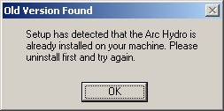
To uninstall the previous version, use the function Add/Remove Programs in the Control Panel, select Arc Hydro Tools and click Change/Remove. Then follow the instructions from the Wizard to uninstall the tools.
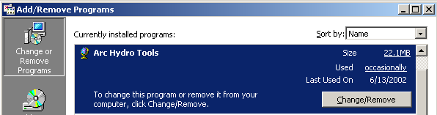
Check the location where the tools were installed and make sure it is empty (note the directory will not be deleted). If some of the Arc Hydro tools dlls are still in the bin directory (ArcHydroTools.dll, ApUtilities.dll, ApFramework.dll or TimeSeriesManager.dll), unregister and delete these files before proceeding with the installation of the new version.
After double-clicking the setup, browse to the desired installation location (use default location): the files will be installed in the bin directory under the destination folder. Follow the instructions to complete the setup.
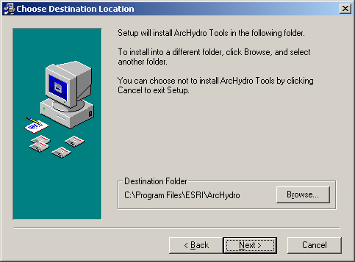
After installing the Arc Hydro Tools, the install may prompt you as to whether to install the XML Parser, that is required to run the tools. If prompted to install MSXML 3.0, say no. The latest version of the Arc Hydro tool install does not ask this question, and just completes the installation automatically.
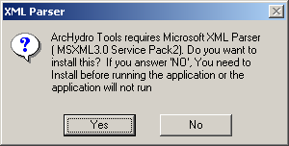
- Select No
- This step is not required by the latest version of Arc Hydro. If you were prompted to install MSXML 3.0 and said no then install MSXML 4.0 separately by running msxml.msi. Follow the instructions to complete the setup.

2. Open ArcMap and load Arc Hydro tools
- Open ArcMap.
- Right click on the menu bar to pop up the context menu showing available tools.
- If the Arc Hydro Tools menu does not appear in the list, click on “Customize”.

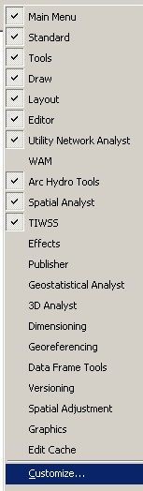

- In the Customize dialog that appears, click Add from file.

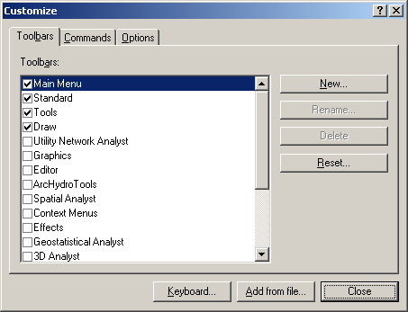

- Browse to C:/Program Files/ESRI/ArcHydro/bin and click on ArcHydroTools.dll.

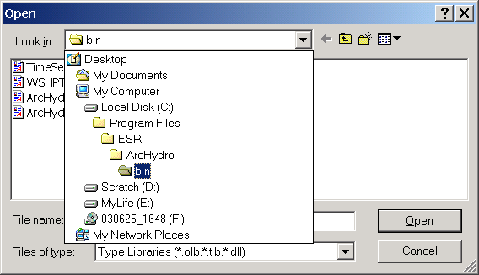
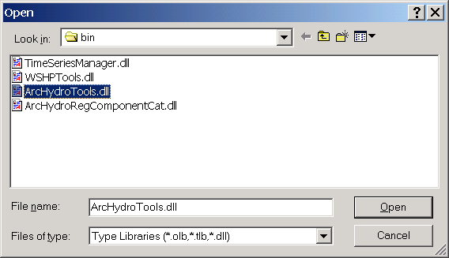

- Click OK to acknowledge the added objects.

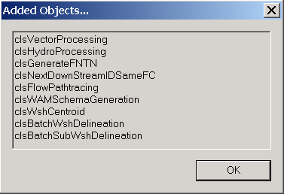

- Now check the Arc Hydro Tools box that should be present.
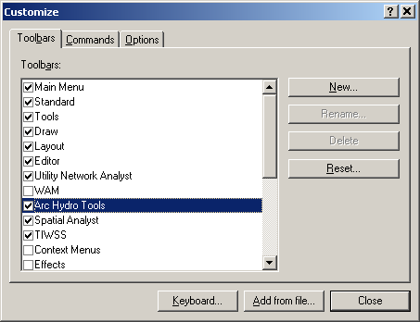
- You should now see the Arc Hydro tools added to ArcMap. You can leave it floating or you may dock it in ArcMap.

Note
It is not necessary to load the Spatial Analyst, Utility Network Analyst, or Editor tools because Arc Hydro Tools will automatically use their functionality on as needed basis. These toolbars need to be loaded though if you want to use any general functionality that they provide (such as general editing functionality or network tracing).
However, the Spatial Analyst Extension needs to be activated, by clicking Tools>Extensions…, and checking the box next to Spatial Analyst.
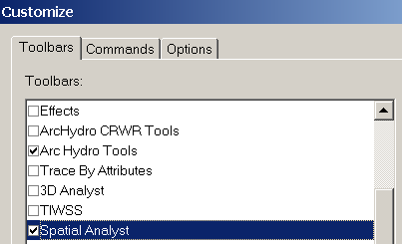

Dataset Setup
The existing data to be used in an Arc Hydro project can be stored in any geodatabase and loaded in the map. All vector data created with the Arc Hydro tools will be stored in a new geodatabase that has the same name as the stored project or ArcMap document (unless pointed to an existing geodatabase) and in the same directory where the project has been saved. By default, the new raster data are stored in a subdirectory with the same name as the dataset or Data Frame in the ArcMap document (called Layers by default and under the directory where the project is stored). The location of the vector, raster, and time series data can be explicitly specified using the function ApUtilities>Set Target Locations.

Data
The following data is needed:
- National Elevation Dataset.
- National Hydrography Dataset.
- Watershed boundary shapefile
- StreamGage table
This data is all in the file Ex4data.zip. Extract the files to a convenient working folder using WinZip. You should find the following folders and files
- \98319986\. This contains the National Elevation Dataset data obtained from the NED online store http://seamless.usgs.gov/ for Reynolds Creek. This data is the newer higher resolution 1/3 arc second (1/3") NED product that is recently available.
- \17050103\. National Hydrography Dataset for HUC 17050103 comprising Reynolds Creek obtained from the USGS http://nhd.usgs.gov/data.html.
- ReyWatershedBoundary.shp. Shapefile giving the Reynolds Creek Watershed boundary
- ReyStreamGages.csv. Comma separated table that includes information on locations of Reynolds Creek Stream gages.
Extract the files to a convenient working folder using WinZip. You should find the following folders
\98319986\. This contains the National Elevation Dataset data we will use.
Both these datasets are in Geographic coordinates so the first thing we need to do is project them. I chose to project them to UTM zone 11 (figure out if this is correct given the longitude). Open ArcToolbox. For this you will require an ArcInfo license. The 'Project Wizard (coverages and grids)' is not included with ArcView. Locate the 'Project Wizard (coverages and grids)' under Data Management Tools/Projections and double click on it.
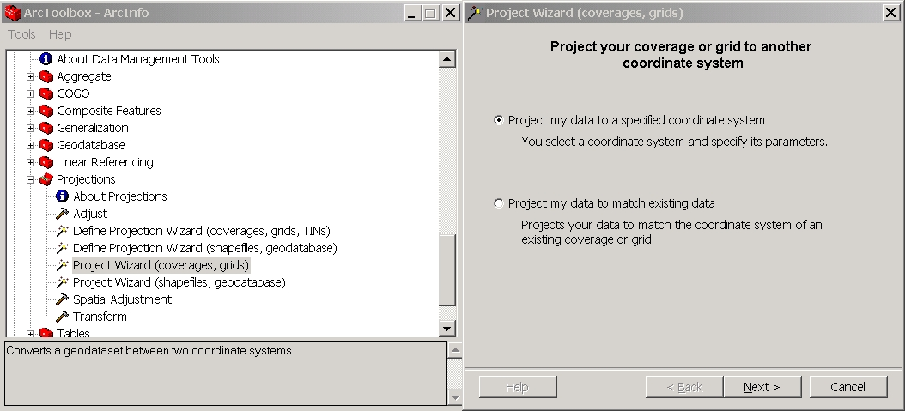
Ensure that 'Project my data to a specified coordinate system is checked and click next. At the 'Choose a coverage or grid to project' dialog click the browse button and look for the NED DEM grid '98319986'and select it then click open.
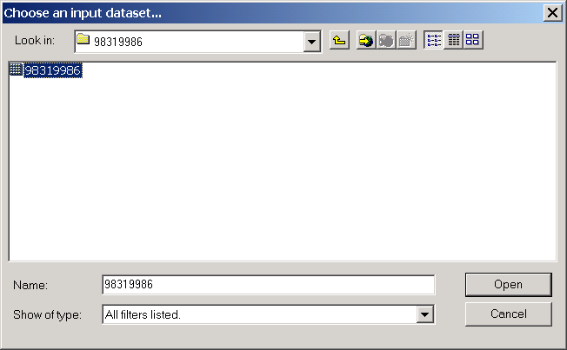
Details of the coordinate system parameters should appear in the dialog. Click next. At the dialog 'What projection do you want your dataset to have' select UTM. Click next. Accept the suggested units (meters), zone 11 and 0 X shift and Y shift. Click next. At the dialog 'What datum do you want your dataset to have' select NAD 1983. Click next. At the specify an output dataset dialog click browse . Find the folder where you will be working. Change 'Save as type' from coverages to grids and specify the name 'ned'. Click 'Save'.
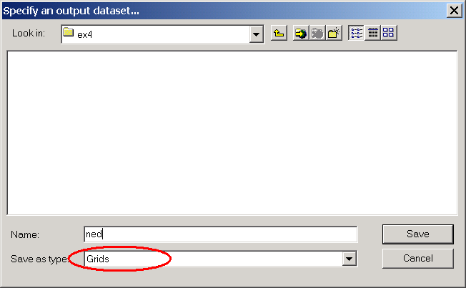
Set the resampling method as 'Cubic'.
Without delving into the theory of the difference between Nearest, Bilinear and Cubic interpolation, I did a bit of experimenting and found that a rather striped dataset results if Cubic resampling is not selected. Feel free to experiment with this yourself and examine the differences using hillshading.
Click the checkbox 'Project will calculate a cellsize. Would you rather you specify your own?' and enter 15 meters to specify that the cell size should be 15 m. The dialog should look like this.
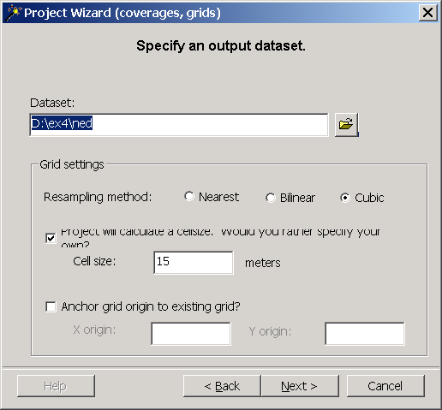
Click next. Review the summary of your input and click finish. Wait a minute or so while the grid is projected. You may obtain an 'Execution error warning' which you can dismiss.
While you are waiting reflect on the fact that this is 1/3" data. The cell size is 1/3 of 1/60 of 1/60 of a degree. Review what you learned in the session 5 lecture on Map Projections and calculate the length on a meridian and length on a parallel of a grid cell of this size at latitude 43ºN. To hand in. Report the grid cell size in both N-S and E-W directions of a 1/3" grid cell at latitude 43ºN. 15 m is chosen because it is slightly larger than the grid cell size you should obtain.
Now follow a similar series of steps to project the nhd coverage to the same coordinate system. The nhd coverage is '17050103\nhd'. Save it in the same location as the DEM using the name 'nhd'. Leave the 'Save as type' set to coverages. Click save, next and finish and wait until the coverage is projected. Dismiss the execution warning error if you get it. Close ArcToolbox. For the remainder of this project you do not need an ArcInfo license. An ArcView licence is sufficient.
You could have bypassed the step of projecting the coverage, because as long as the coverage has projection information (which NHD coverages do) ArcMAP will project on the fly and work with the data correctly. If you do not have ArcInfo you can also bypass the need to use the Project Wizard for grids by using Spatial Analyst. The grid in geographic coordinates can be loaded in to a data frame that has a projected coordinate system, invoking on the fly grid projection. This grid can then be evaluated in Spatial Analyst setting the output coordinate system to be the same as the active data frame. The extent and cell size should also be specified. Spatial Analyst will then use some form of interpolation to calculate a projected grid. This method does not provide control over the interpolation method used.
Open ArcMap. Add the data 'ned' and 'nhd\route.rch' [or the unprojected '17050103\nhd\route.rch']. While loading the dataset 'ned' if prompted click OK to build pyramids. Adjust the symbology to your taste, e.g. blue rivers and a nice shading for the elevation dataset. Dismiss the warning about the elevation dataset having more than 2048 unique values and therefore no raster table. We will not need a raster table. Examine the source tab under layer properties associated with 'ned' to see the number of rows and columns and cellsize associated with this dataset.
Save your ArcMap document in the location you want your results files to appear using a name you choose (e.g. Ex4.mxd). You need to have saved the ArcMap document before using any ArcHydro functions because it needs to create an output folder in the folder where the map document is saved.

Terrain Preprocessing
Terrain Preprocessing uses DEM to identify the surface drainage pattern. Once preprocessed, the DEM and its derivatives can be used for efficient watershed delineation and stream network generation.
All the steps in the Terrain Preprocessing menu should be performed in sequential order, from top to bottom. All of the preprocessing must be completed before Watershed Processing functions can be used. DEM reconditioning and filling sinks might not be required, depending on the quality of the initial DEM. DEM reconditioning involves modifying the elevation data to be more consistent with the input vector stream network (NHD). This implies an assumption that the stream network data is more reliable than the DEM data, so you need to use knowledge of the accuracy and reliability of the data sources when deciding whether to do DEM reconditioning. By doing the DEM reconditioning you can increase the degree of agreement between stream networks delineated from the DEM and the input vector stream network (NHD).
Be aware, some of the terrain processes may take some time to finish. Process like Filling Sinks and Flow accumulation took about 10 minutes to process on one of our computers, so please be patient!

1. DEM Reconditioning
This function modifies a DEM by imposing linear features onto it. It is an implementation of the AGREE method developed at the University of Texas at Austin in 1997. For a full reference to the procedure refer to the web link http://www.ce.utexas.edu/prof/maidment/GISHYDRO/ferdi/research/agree/agree.html.
The function needs as input a raw dem and a linear feature class (like the river network) that both have to be present in the map document.
From the ArcHydro toolbar select Terrain Preprocessing | DEM Reconditioning.
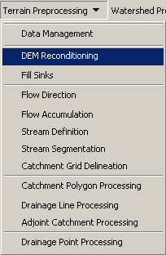
Select the appropriate dem (ned) and linear feature (nhd route.rch). The output is a reconditioned Agree DEM (default name AgreeDEM).
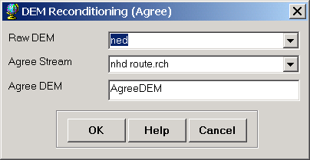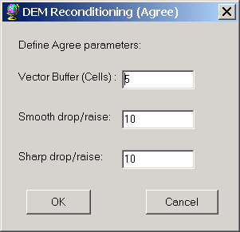
Examine the folder where you are working you will notice that a folder named Layers has been created. This is where ArcHydro outputs its grid results. A personal geodatabase with the same name as your ArcMap document has also been created. This is where ArcHydro outputs its vector feature class data.
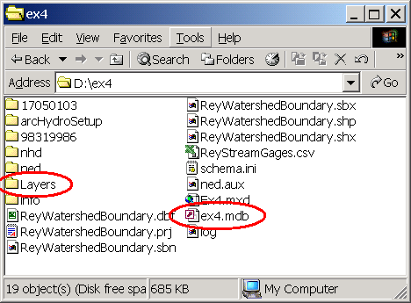
If you are curious you can use 3D analyst to examine what AGREE has done to the DEM
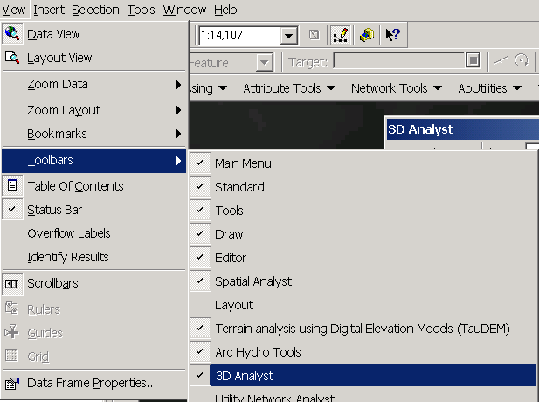
Use the Interpolate Line and Create Profile Graph tools to examine a profile cross section across a stream.
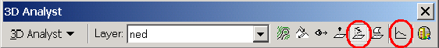
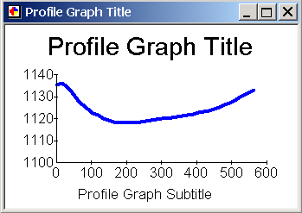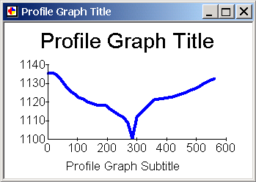

2. Fill Sinks
This function fills the sinks in a grid. If cells with higher elevation surround a cell, the water is trapped in that cell and cannot flow. The Fill Sinks function modifies the elevation value to eliminate these problems.
Select Terrain Preprocessing | Fill Sinks.
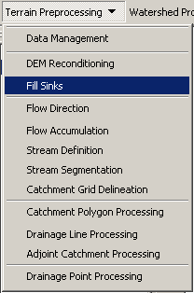
Confirm that the input for DEM is “AgreeDEM” (or your original DEM if Reconditioning was not implemented). The output is the Hydro DEM layer, named by default “Fil”. This default name can be overwritten.
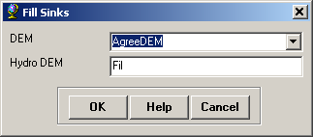
Press OK. Upon successful completion of the process, the “Fil” layer is added to the map.
This process takes up to 10 minutes!

3. Flow Direction
This function computes the flow direction for a given grid. The values in the cells of the flow direction grid indicate the direction of the steepest descent from that cell.
Select Terrain Preprocessing | Flow Direction.
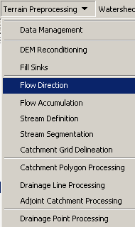
Confirm that the input for Hydro DEM is “Fil”. The output is the Flow Direction Grid, named by default “Fdr”. This default name can be overwritten.
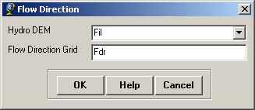
Press OK. Upon successful completion of the process, the flow direction grid “Fdr” is added to the map.
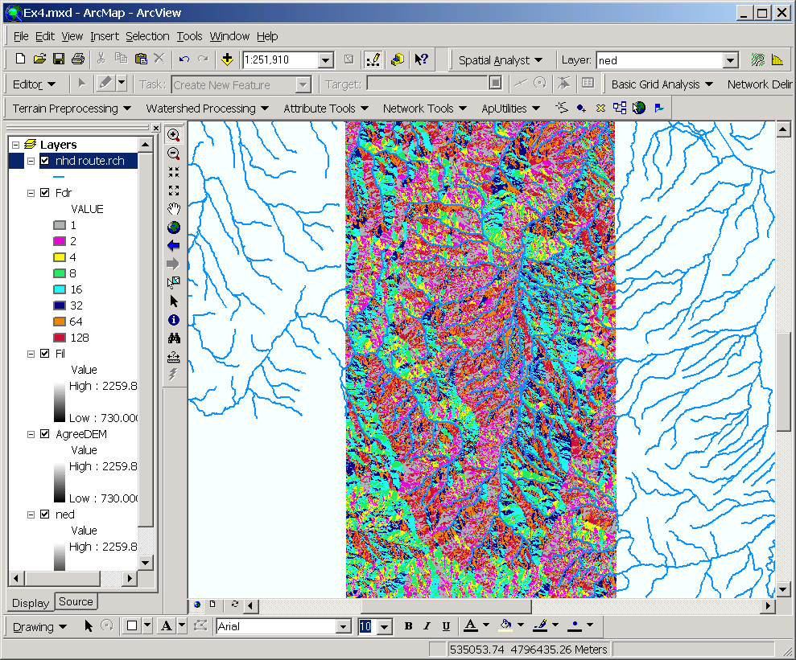
To be turned in: Make a screen capture of the attribute table of Fdr and give an interpretation for the values in the Value field using a sketch.

4. Flow Accumulation
This function computes the flow accumulation grid that contains the accumulated number of cells upstream of a cell, for each cell in the input grid.
Select Terrain Preprocessing | Flow Accumulation.
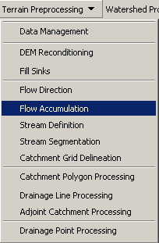
Confirm that the input of the Flow Direction Grid is “Fdr”. The output is the Flow Accumulation Grid having a default name of “Fac” that can be overwritten.
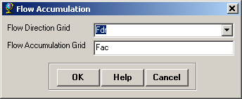
Press OK. Upon successful completion of the process, the flow accumulation grid “Fac” is added to the map. Add the ReyWatershedBoundary.shp shapefile to the map and adjust the symbology of Fac. Use Spatial Analyst to generate contours of the original DEM so that you can examine flow accumulation relative to the terrain as depicted by contours and relative to the NHD streams. The following shows Fac in the neighborhood of the watershed outlet. The contour interval is 20m.
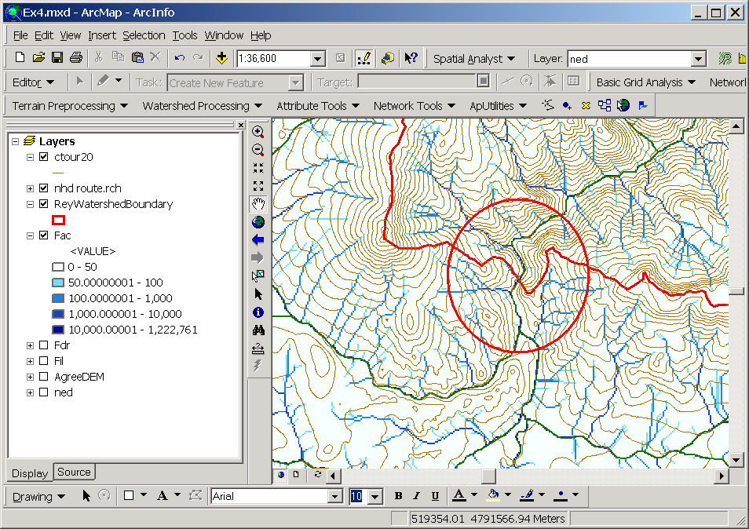

5. Stream Definition
This function computes a stream grid which contains a value of "1" for all the cells in the input flow accumulation grid that have a value greater than the given threshold. All other cells in the Stream Grid contain no data.
Select Terrain Preprocessing | Stream Definition.
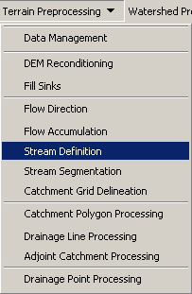
Confirm that the input for the Flow Accumulation Grid is “Fac”. The output is the Stream Grid. “Str” is its default name that can be overwritten.
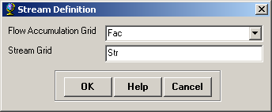
A default value is displayed for the river threshold. This value represents 1% of the maximum flow accumulation: a simple rule of thumb for for the stream determination threshold. Change the threshold to 20000 cells to conform to the EDNA catchment data definition. The threshold drainage area to generate a stream is then 20000 x 15 x 15 / 1000000 = 4.5 km². The 450 km² value that shows in the screen below is an error that needs to be corrected in the toolset. (EDNA actually uses 5000 x 30 x 30 m grid cells). A smaller threshold will result in denser stream network and usually in a greater number of delineated catchments. Objective approaches for the determination of this threshold based on the stream drop property are implemented in TauDEM which will be used later.
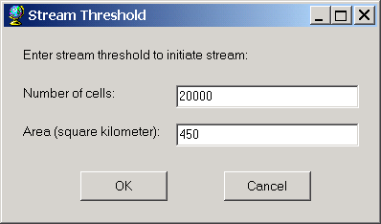
Press OK. Upon successful completion of the process, the stream grid “Str” is added to the map.
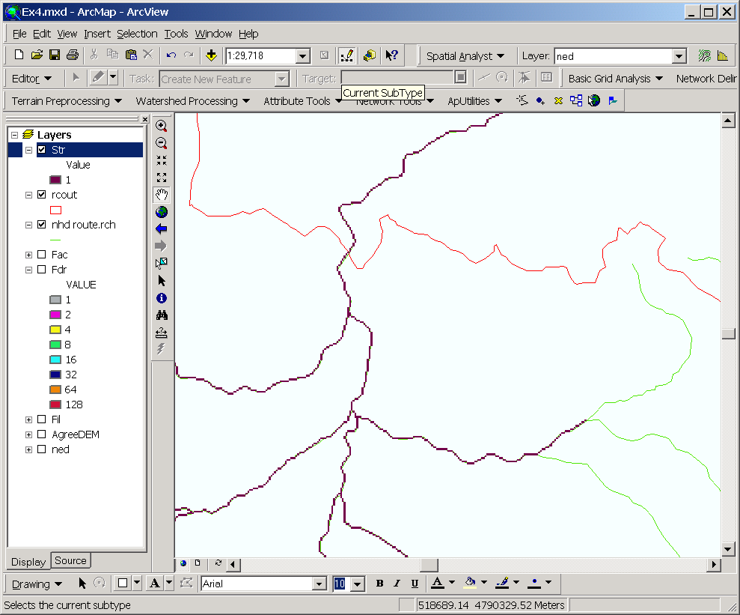

6. Stream Segmentation
This function creates a grid of stream segments that have a unique identification. Either a segment may be a head segment, or it may be defined as a segment between two segment junctions. All the cells in a particular segment have the same grid code that is specific to that segment.
Select Terrain Preprocessing | Stream Segmentation.
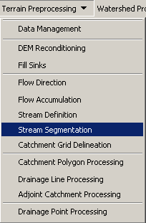
Confirm that “Fdr” and “Str” are the inputs for the Flow Direction Grid and the Stream Grid respectively. The output is the Link Grid, with the default name “Lnk” that can be overwritten.
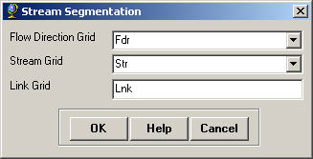
Press OK. Upon successful completion of the process, the link grid “Lnk” is added to the map.
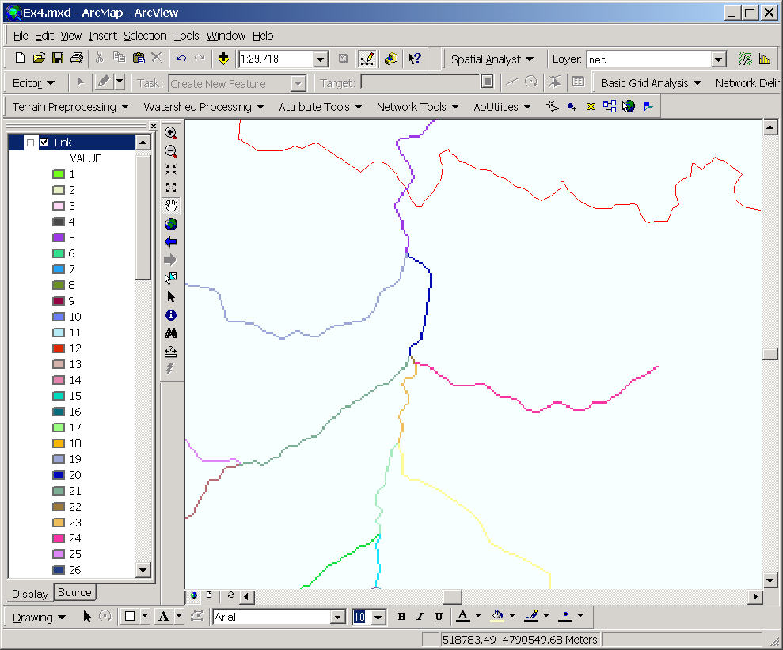
Notice how at this point each link has a separate value.

7. Catchment Grid Delineation
This function creates a grid in which each cell carries a value (grid code) indicating to which catchment the cell belongs. The value corresponds to the value carried by the stream segment that drains that area, defined in the stream segment link grid
Select Terrain Preprocessing | Catchment Grid Delineation.
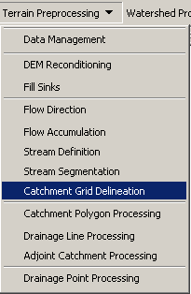
Confirm that the input to the Flow Direction Grid and Link Grid are “Fdr” and “Lnk” respectively. The output is the Catchment Grid layer. “Cat” is its default name that can be overwritten by the user.
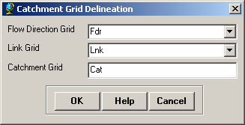
Press OK. Upon successful completion of the process, the Catchment grid “Cat” is added to the map. You can recolor it with Unique Values to get a nice display
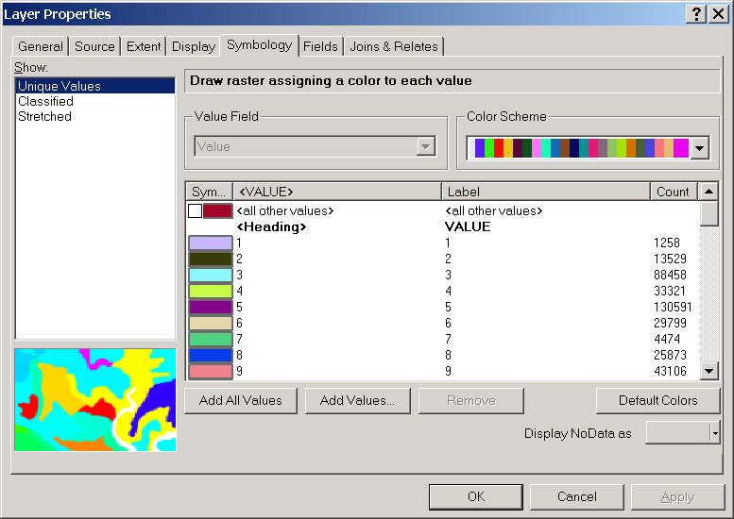
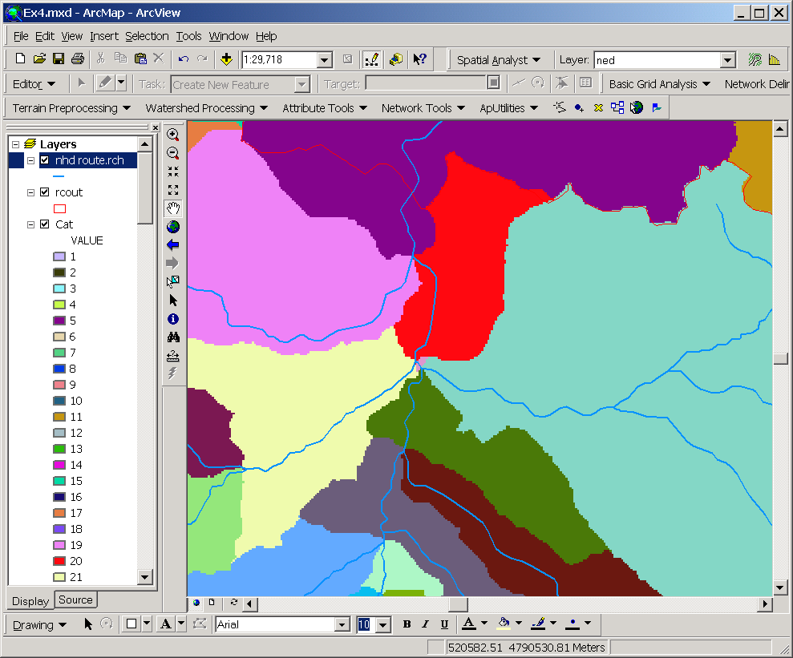

8. Catchment Polygon Processing
This function converts a catchment grid into a catchment polygon feature.
Select Terrain Preprocessing | Catchment Polygon Processing.
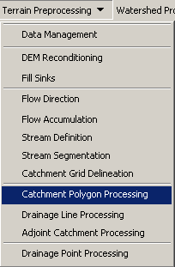
Confirm that the input to the CatchmentGrid is “Cat”. The output is the Catchment polygon feature class, having the default name “Catchment” that can be overwritten.
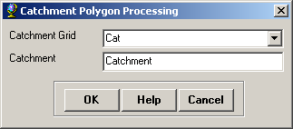
Press OK. Upon successful completion of the process, the polygon feature class “Catchment” is added to the map.
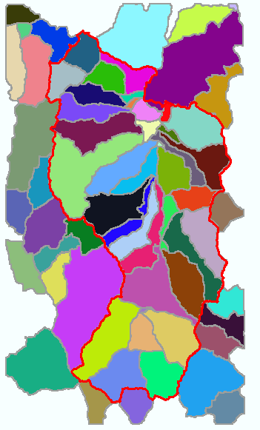

9. Drainage Line Processing
This function converts the input Stream Link grid into a Drainage Line feature class. Each line in the feature class carries the identifier of the catchment in which it resides.
Select Terrain Preprocessing | Drainage Line Processing.
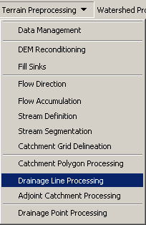
Confirm that the input to Link Grid is “Lnk” and to Flow Direction Grid “Fdr”. The output Drainage Line has the default name “DrainageLine”, that can be overwritten.
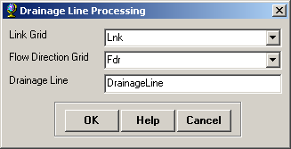
Press OK. Upon successful completion of the process, the linear feature class “DrainageLine” is added to the map.
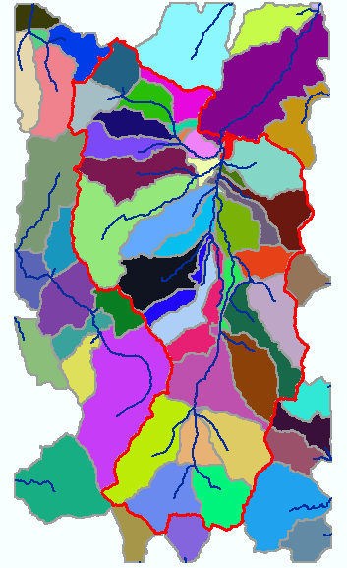
To be turned in: A layout showing the delineated Catchments and DrainageLines

10. Adjoint Catchment Processing
This function generates the aggregated upstream catchments from the "Catchment" feature class. For each catchment that is not a head catchment, a polygon representing the whole upstream area draining to its inlet point is constructed and stored in a feature class that has an "Adjoint Catchment" tag. This feature class is used to speed up the point delineation process.

- Select Terrain Preprocessing | Adjoint Catchment Processing.

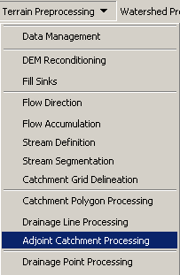
Confirm that the inputs to Drainage Line and Catchment are respectively “DrainageLine” and “Catchment”. The output is Adjoint Catchment, with a default name “AdjointCatchment” that can be overwritten.
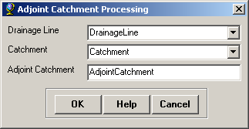
Press OK. Upon successful completion of the process, the polygon feature class “AdjointCatchment” is added to the map.
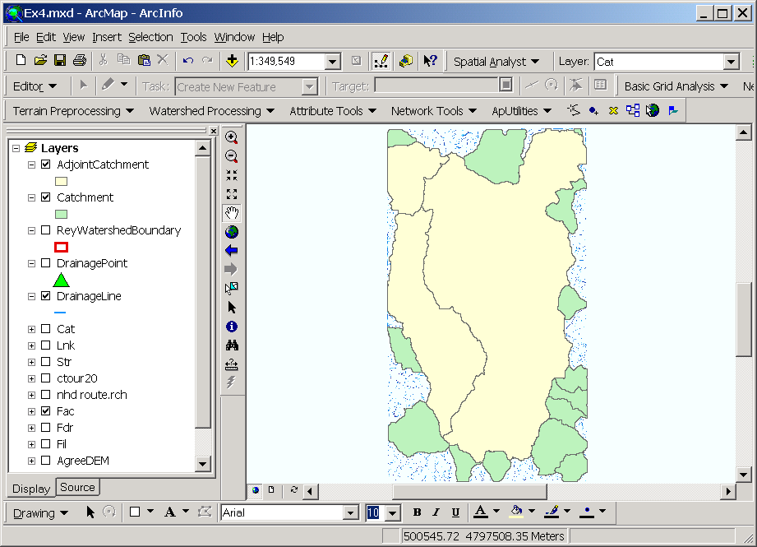

11. Drainage Point Processing
This function allows generating the drainage points associated to the catchments.

- Select Terrain Preprocessing | Drainage Point Processing.

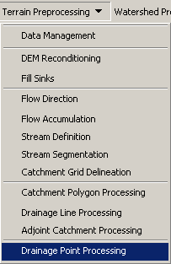

Confirm that the input to Drainage Line is “DrainageLine”, and the input to Catchment is “Catchment”. The output is Drainage Point, having the default name “DrainagePoint” that can be overwritten.
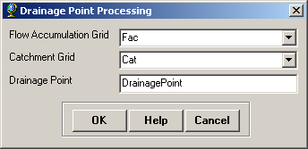
Press OK. Upon successful completion of the process, the point feature class “DrainagePoint” is added to the map.
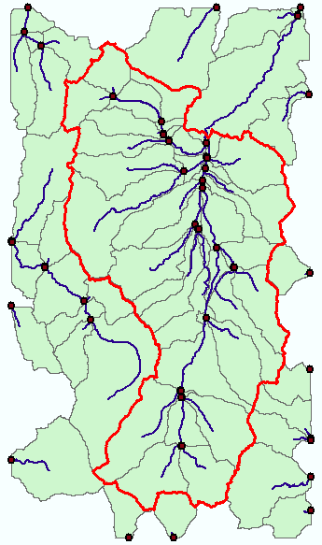
To be Turned In: How many DrainagePoints, DrainageLines and Catchments are there? What is the ID field in each feature class that associates the appropriate DrainagePoint with its DrainageLine and Catchment? Make a graphic showing how one associated DrainagePoint, DrainageLine and Catchment are related.

Watershed Processing
Now, lets explore the data that we’ve created. Turn off all the themes in the display, except for the original Digital Elevation Model. From the Arc Hydro tools, select the Flow Path Tracing button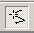 and click on a few places on the elevation model. You’ll see flow paths traced to the watershed outlet. This path is traced using the Flow Direction grid created earlier in the exercise.
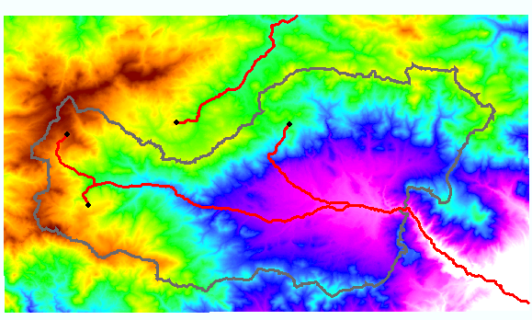
The flow paths just created are graphics. They can be deleted from the map by using the Select Elements tool in the ArcMap Draw toolbar, drawing a box around the graphics and then using the Delete key.
To be Turned In: A graphic showing drainage paths traced over the digital elevation model.
Now lets take a look at the Flow Accumulation. Turn on the Fac Grid, and the DrainageLine theme. Make a Drainage Path trace, and notice how the path follows the drainage lines.
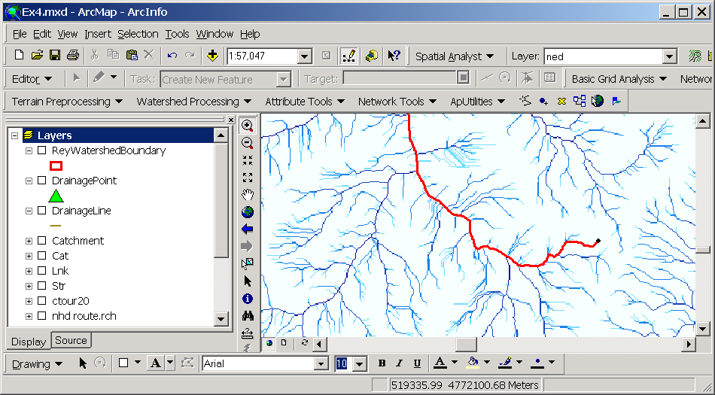
Zoom in on a part of the trace, and notice how the DrainageLines (blue) are exactly coincident with the Flow Accumulation cells with high flow accumulation values. The Flow Accumulation grid has here been colored to light to dark blue to make this contrast easier to see:
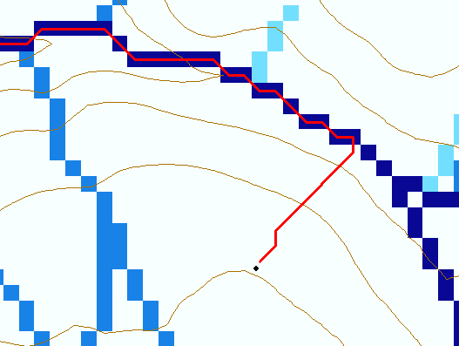
Use the Identify tool in the Tools toolbar to get the flow accumulation values along a DrainageLine. Notice how the flow accumulation increases as you go downstream, and how it jumps as you go over a confluence in the streams.
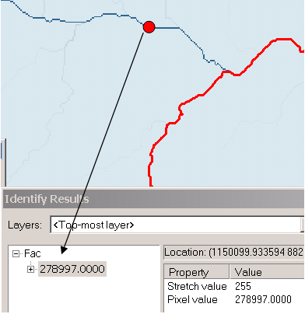
To be turned in: A graphic showing an Identify enquiry on the Flow Accumulation Grid
Zoom in right close to the outlet and with the Flow Accumulation Grid visible, use the 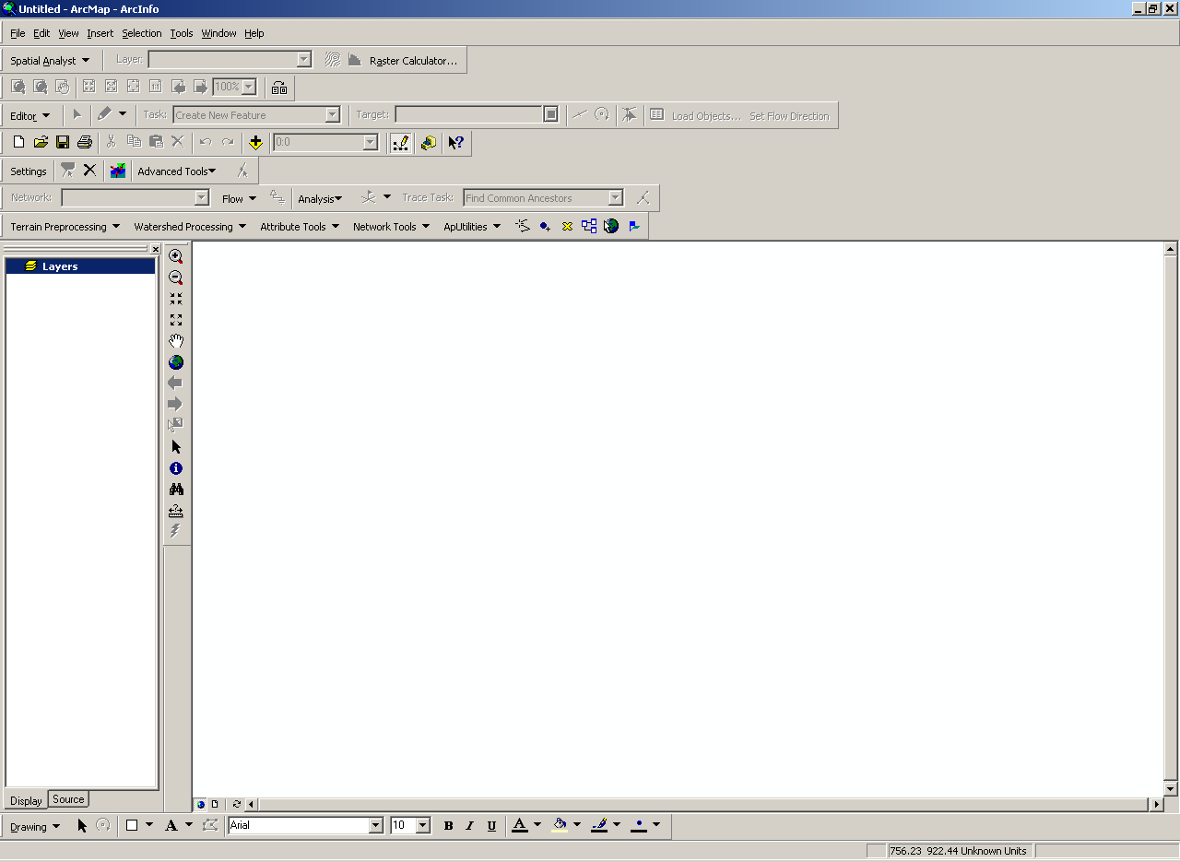 tool to examine the values of the various grids near where the stream exits the watershed.
To be turned in: What is the flow accumulation in number of cells where the stream leaves this watershed. What is the cell size? What drainage area does this correspond to in km²? Draw a series of 5 x 5 grids on paper and based upon the template below fill in the following information
- Initial elevation
- AGREE conditioned elevation
- Pit filled elevation
- Flow direction (depict with arrows)
- Flow accumulation area
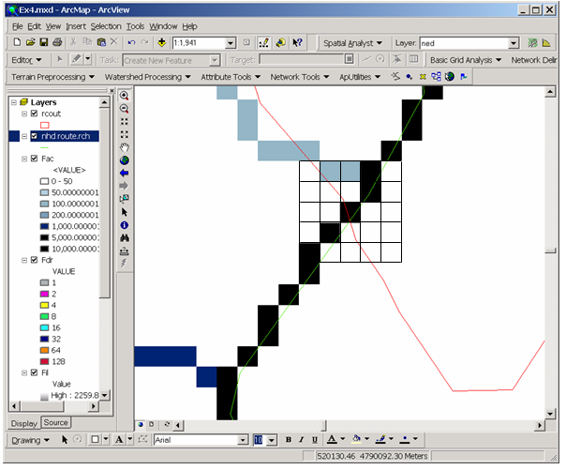
Tracing
As part of the Catchment processing, the NextDownID attribute has been populated for each Catchment and Stream Segment so that it knows which Catchment or Stream segment is next downstream. Click on the Trace by NextDownID tool and Select Catchment as the theme to be traced, and Trace Upstream as the action. Click in a Catchment that has others upstream, and you’ll see the upstream Catchments traced out. Pretty cool!
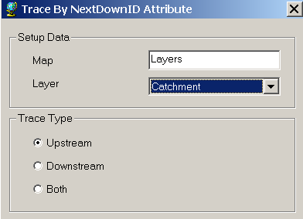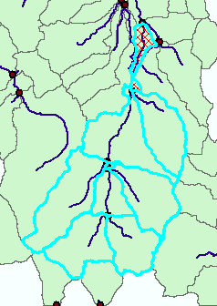
You can similarly trace downstream, and both upstream and downstream to define the “Region of Hydrologic Influence” of any Catchment/Stream Segment. In order to invoke the NextDownID tracing tool a second time, it is necessary first to click another tool first, such as the Select Element tool in the Tools toolbar. This shows the Trace Both applied to Drainage Lines.
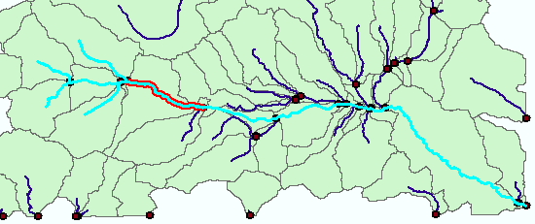
To be Turned In: A graphic showing the Region of Hydrologic Influence of your chosen catchment.

Point Watershed Delineation
We can delineate the watershed from an arbitrarily chosen point on the delineated stream network. Turn on the DrainageLine feature class so you can see where the drainage lines are located. Use the Point Delineation tool to select a point on the DrainageLine and then you’ll see the watershed delineated to that point (or sometimes to a location slightly downstream of the point for reasons not entirely clear)

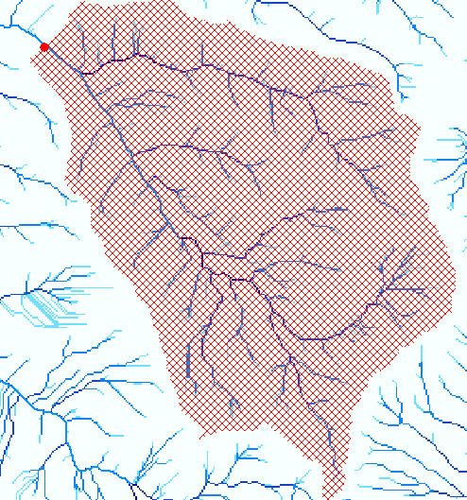

You’ll be prompted for some information about the point you’ve just used:
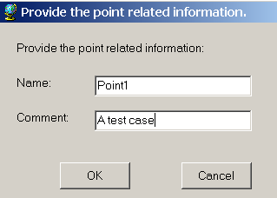

When you fill this in, the graphic just created is deleted. Feature Classes Watershed and WatershedPoint are added.
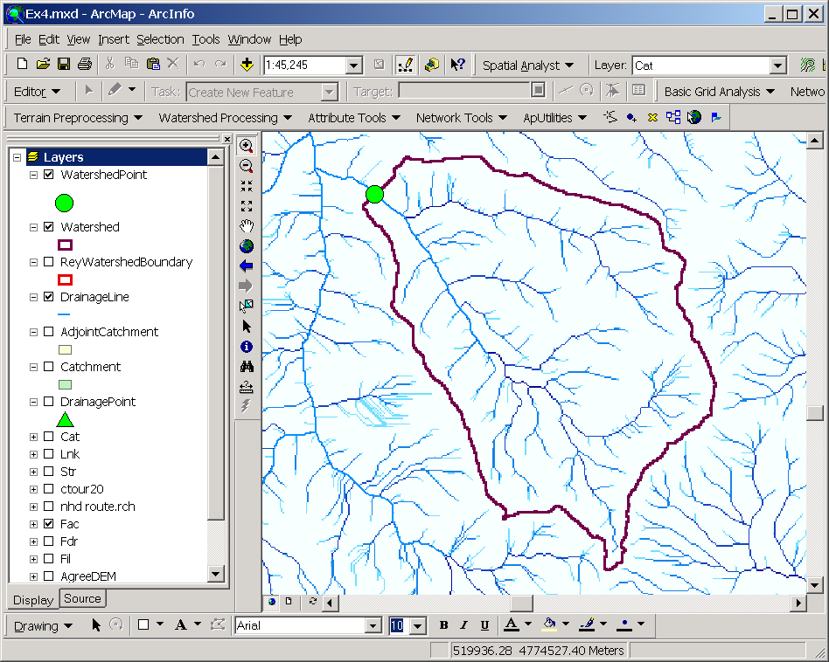
Delineating Watersheds from Stream Gages
Coordinates of streamgages in the Reynolds Creek Experimental Watershed are given in the file 'ReyStreamGages.csv' included in the zip file. This information is from Seyfried, M. S., R. C. Harris, D. Marks, and B. Jacob, A geographic database for watershed research: Reynolds Creek Experimental Watershed, Idaho, USA, Tech. Bull. NWRC 2000-3, 26 pp., Northwest Watershed Res. Cent., Agric. Res. Serv., U.S. Dep. of Agric., Boise, Idaho, 2000. Only streamgages draining more than 1000 ha have been included here.
Use the (Add Data) button to add the data table 'ReyStreamGages.csv'. This file should then appear in the table of contents (source tab) of the active data frame, but not on the map, because the system does not (yet) know how to interpret the data geographically.
Right click on this table of contents entry and select Open This displays in tabular form the data read from file 'ReyStreamGages.csv'.
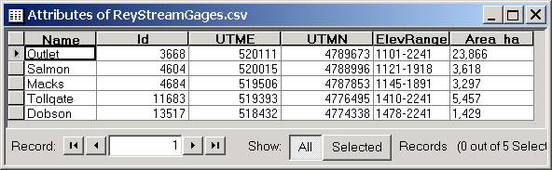
Note that there are fields named UTME and UTMN that give the locations of the Streamflow stations. Close the table.
Right click on the table of contents entry for 'ReyStreamGages.csv' and select display XY data.
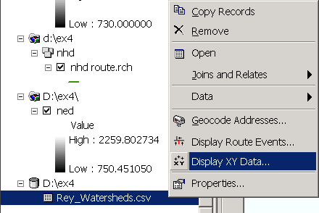
At the display XY data dialog adjust the X field to UTME and Y field to UTMN. Click on Edit to set the Coordinate System.
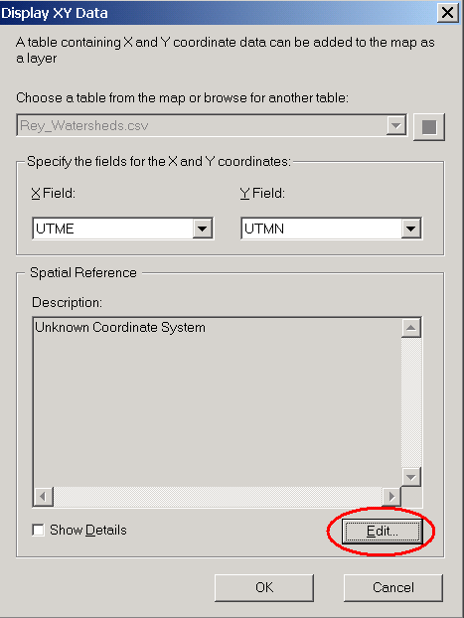
Select a predefined coordinate system and browse to Projected Coordinate Systems/UTM/NAD 1927/NAD_1927_UTM_Zone_11N. Click Add. The report that this data was obtained from says that it is in the UTM coordinate system with NAD 1927 datum.
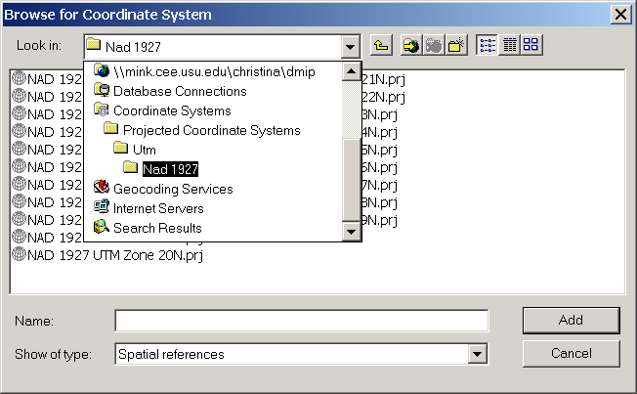
At the Spatial Reference Properties dialog, OK and OK again.
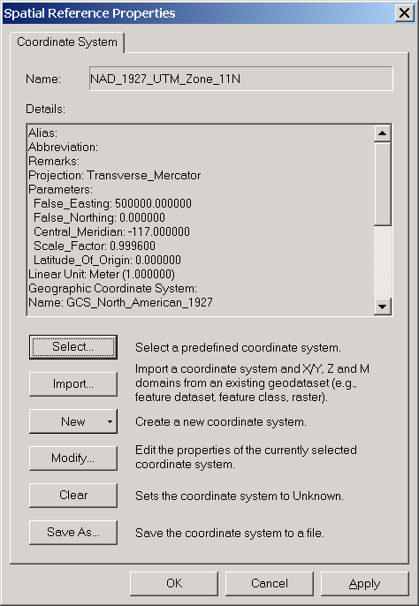
The Streamgage locations should now be displayed on the map. These need to be imported to the Geodatabase for ArcHydro to use them.
Right click on ReyStreamGages.csv Events theme in the map display and select Data/Export Data and add the exported data to the Ex4 personal geodatabase as a feature class named Outlet in the Layers feature dataset.
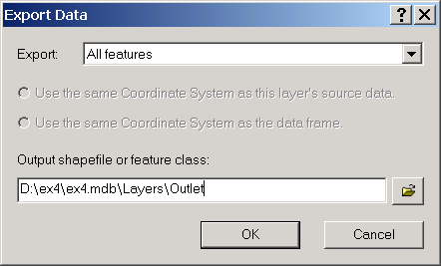
Click Yes to add this feature class to the map display and turn off the display for the ReyStreamGages.csv Events theme.
If you zoom in, you’ll see that the stream gages are not located precisely on the DrainageLines. In the display below drainage lines are shown together with flow accumulation Fac.
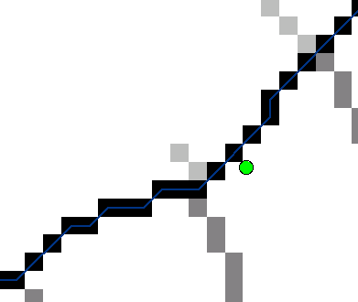
To make outlets for watersheds, we need outlet points need to be precisely located within a grid cell of the flow path where they occur.
Open the Editor menu from the View/Toolbars and select Start Editing. Select the Ex4 geodatabase as the target for editing so that you can edit the Outlet features. Using Editor/Snapping, click on the snapping to the DrainageLine feature class:
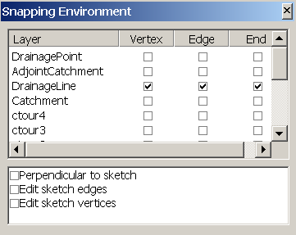
Set the Edit targets to Modify Feature for the Outlet feature class.
Click on the tool, zoom in to each of the outlets and drag it so that it snaps onto the DrainageLine. When you get close to the line, you’ll see the point leap over and snap itself onto the line. Pretty cool!
In deciding the placement of points you should check the given area and Flow accumulation value. A flow accumulation of 1060087 grid cells x 15 x 15 gives 238519575 m² = 23851.96 ha. This compares favorably with the 23866 ha drainage area for that location.
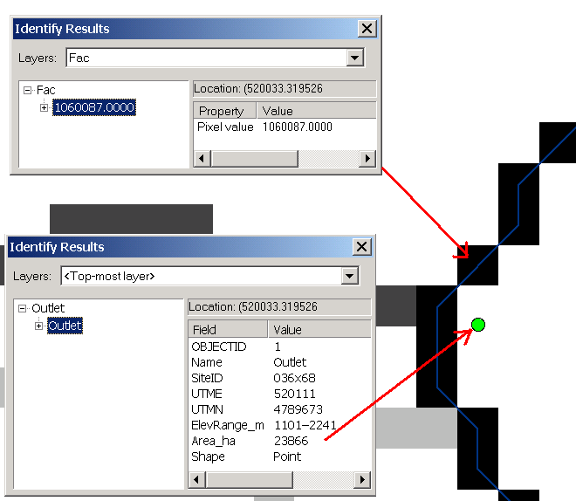
The position after editing is given below.
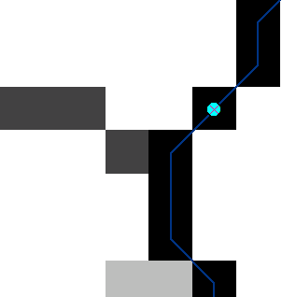
For some locations there is no nearby stream or high contributing area. Some of the stream gages have very small drainage area. Just leave these points where they are. After editing each point, use Editor/Save Edits to your edits and Editor/Stop Editing to close out the Edit session. Ok, now for the cool part. Use Watershed Processing/Batch Subwatershed Delineation to get subwatersheds for each streamgage and for the outlet:
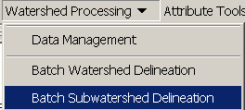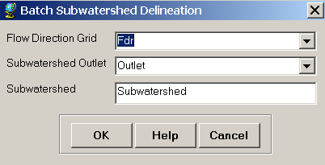
Hit OK, and after quite some time of processing (~ 3 minutes), you should see the following result appear. Voila!!
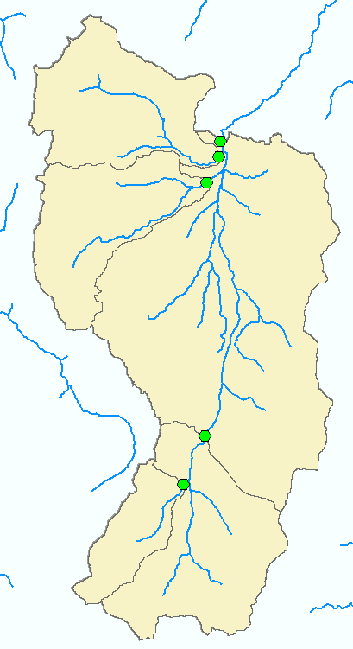
You can add the DrainageLines and Outlets and recolor the watershed boundaries to get a nicer display. This is pretty cool. What you have just done is to delineate the drainage areas of a set of selected locations in your basin. This may look pretty routine but until the DEM processing method became available, this same task would have taken days of interpretation of dozens of 1:24,000 scale topographic paper maps to achieve the same result!
To be turned in: A graphic of the delineated subwatersheds, and a table showing the subdrainage area and the total drainage area in km² for each gage and for the basin as a whole.

Part B. TauDEM
We will now delineate channel networks from the 'ned' digital elevation model using the TauDEM tool. This tool also provides advanced capability to delineate channel networks using alternative algorithms, such as the contributing area of upwards curved grid cells and to use the constant drop test to objectively determine drainage density. To obtain TauDEM go to http://moose.neng.usu.edu/taudem/taudem.html. Download the file TauDEMSetup.zip and install the software. This has already been done in the USU geomatics lab. This website also contains help for using TauDEM in standalone mode.
Open ArcMAP and add the TauDEM toolbar. Click on tools | Customize | Add from file and select the file c:\program files\Common Files\Mapwindow2.7\Plugins\agtaudem.dll
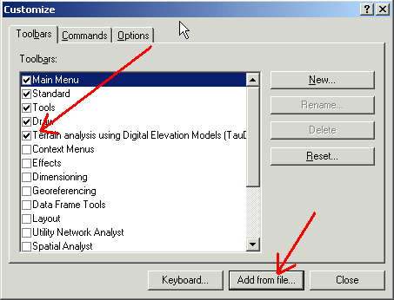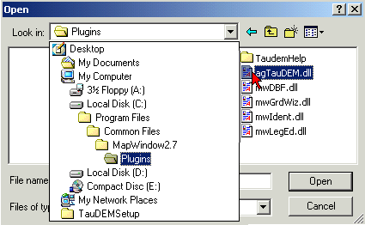
You should get a toolbar that looks like
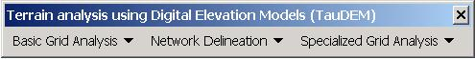
This may be docked.
On the TauDEM toolbar from the Grid Analysis menu 'Select Base DEM grid ...'. You should get a dialog like this:
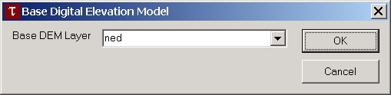
Adjust the Base DEM Layer to be 'ned' and click OK. Next, from the Grid Analysis menu select 'Fill pits'
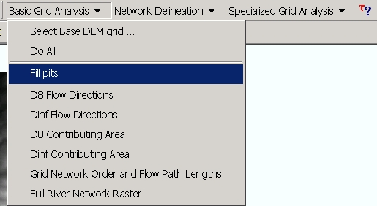
Check at the dialog that opens that the input grid is 'ned' an the output one 'nedfel'. Ignore the Flow Path Grid items for now.
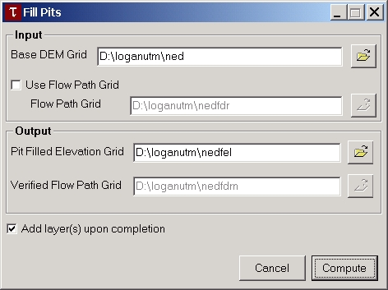
Click on Compute and wait for a few minutes (or more) for the job to complete.
Each of the remaining command under the grid analysis menu can be run in sequence from top to bottom. The program will provide suggested file names for the outputs that follow the convention described in the documentation and given below so you can just click compute at each dialog and have the command execute. [You may learn a bit more about each file by clicking on the file box label in the dialog box associated with each command. You can change the names of input and output grids if you like by editing in the textboxes or using the Browse buttons. If you get an 'Error 1' it means that one of the input grid names specified has a problem. This is commonly caused if commands are run out of sequence.]
Here we will shortcut running each command by selecting the 'Do all preprocessing' command from the 'Grid Processing' menu to have all results generated without any prompts or interuption. Processing of this will take 3 to 5 minutes for the Reynolds Creek DEM. You should answer OK to the prompt to overwrite the existing 'nedfel' file that you created above or else the automatic processing will stop. A number of output layers will be added to the map. The name suffixes designate the contents according to the file naming convention in the documentation and given below. Examine these grid layers to understand their contents.
The last grid calculated, named 'nedsrc' is the stream definition raster equivalent to Str calculated by ArcHydro. To proceed further and delineate watersheds a shapefile containing outlet points needs to be used. Here we will export the Outlet feature class used in ArcHydro. Add the Feature Class Outlet used previously to ArcMap. Right Click on the name 'Outlet' and select Data|Export Data and export the outlets as a shape file named 'Outlet' and say yest to add to the display. Zoom in right near the outlet at the north end and edit the main outlet point to lie on the stream definition raster 'nedsrc'. Depending upon the editing of Outlet in the ArcHydro processing this editing may not be necessary.
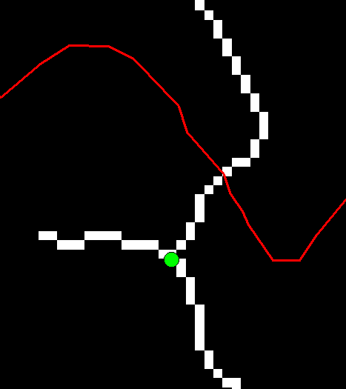  Before Editing | 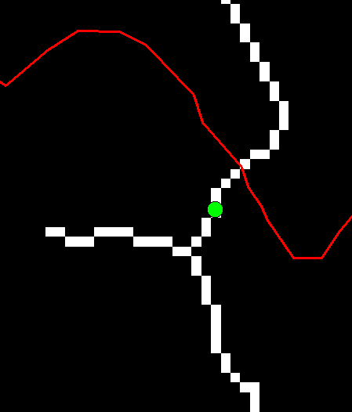  After Editing
Select Editor/Stop Editing and Save edits.
Now select TauDEM/Network Delineation/Select Outlets Shapefile ... Browse to select the shapefile and click Open and OK. Now select TauDEM/Network Delineation/Do All Network and Watershed Delineation steps. A channel network and watersheds are delineated. When outlets have been specified TauDEM is able to automatically do a constant drop using an upwards curved drainage area threshold to delineate channels. The channel network shapefile 'nednet.shp' has an attribute table that includes among other fields the stream order. This can be used in symbology to indicate stream order by different colors or line thickness.
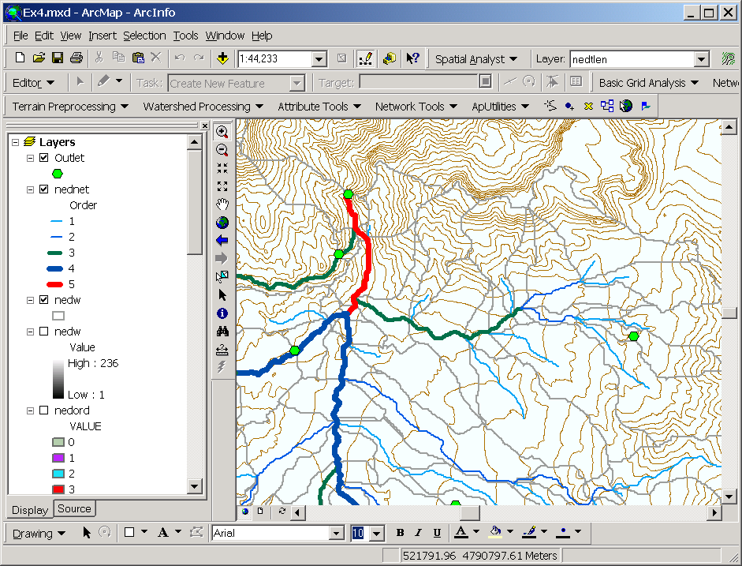
To hand in. Prepare a layout map of Reynolds Creek showing the TauDEM delineated channel network and watersheds draining to each stream segment. On this layout indicate stream orders in different colors or symbols.
The command 'TauDEM/Network Delineation/River Network Raster Upstream of Outlets' enters a dialog that allows you to select different channel network delineation algorithms and their parameters.
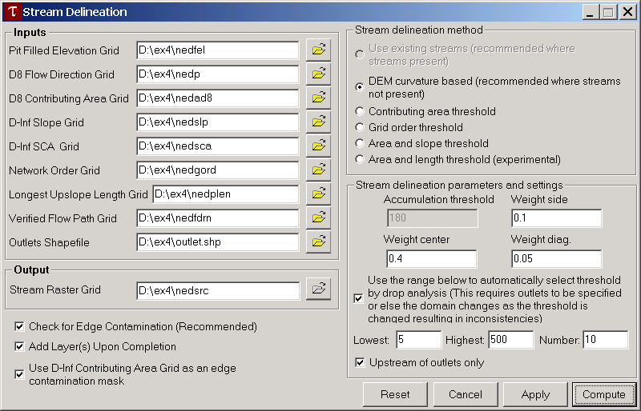
The automatic threshold selection by drop analysis is only possible when outlets are used. After the command has been run the accumulation threshold parameter selected by the constant drop procedure is updated and appears in the grayed Accumulation threshold window above.
To hand in. Report the threshold selected by the constant drop procedure with the DEM curvature based method for Reynolds Creek.
Rerun the command 'Network Delineation/River Network Raster Upstream of Outlets' but select the "Contributing Area Threshold" method and set the constant drop search to be between 50 and 5000.
To hand in. Report the contributing area threshold selected by the constant drop procedure with the Contributing area method.
The command 'Network Delineation/Constant Drop Analysis' shows details of the constant drop analysis that can be used to objectively determine drainage density based upon topographic texture and that is invoked automatically by default controlled by a checkbox within the 'Compute Raster of Network Upstream of Outlets' dialog. The 'Constant Drop Analysis' also reports the drainage density associated with different channel delineation thresholds. The constant drop analysis uses the last method set under the command Network Delineation/River Network Raster Upstream of Outlets'
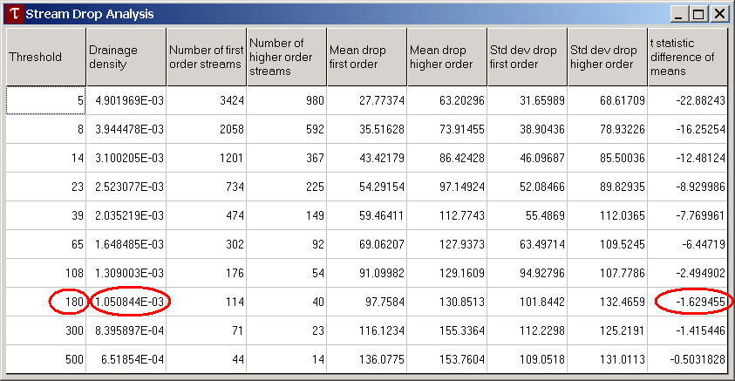
To hand in. Report the drainage density identified from the constant drop procedure with the curvature based and contributing area methods.

Drainage Density Analysis
Recall that drainage density is Total Channel Length/Drainage area. The objective here is to evaluate the drainage density obtained using each of the channel network delineation methods.
1. ArcHydro Network.
Arrange your ArcMap table of contents (which may be quite cluttered by now – feel free to delete unwanted themes. Deleting themes does not delete the data.) so that the DrainageLine and Subwatershed themes are visible.
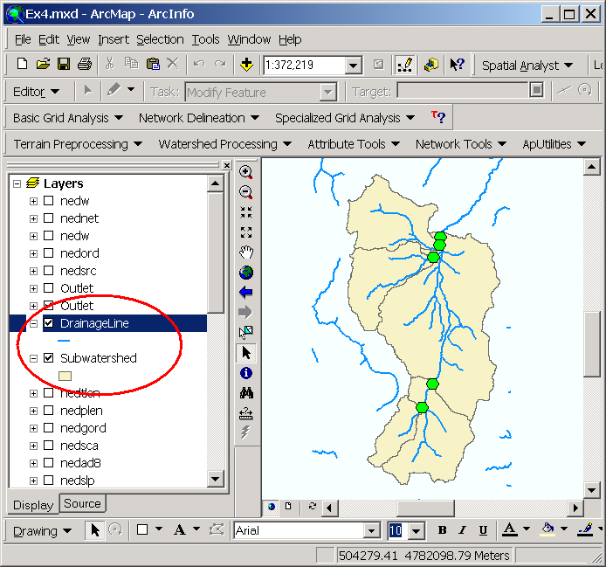
Open the attribute table of Subwatershed. Right click on the Shape Area field header and select statistics.
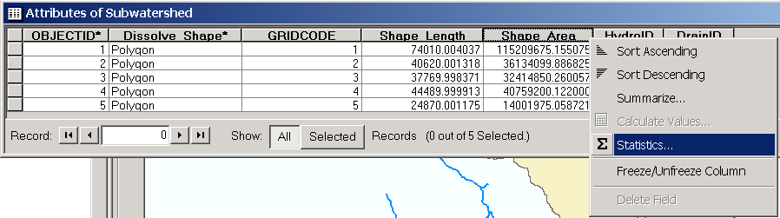
The 'Sum' in the box that pops up gives the total drainage area in m² . This should correspond to the drainage area that you calculated from Flow Accumulation at the outlet earlier.
Choose Selection/Select By Location
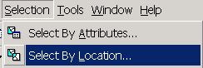
Select features from DrainageLine that intersect features in Subwatershed.
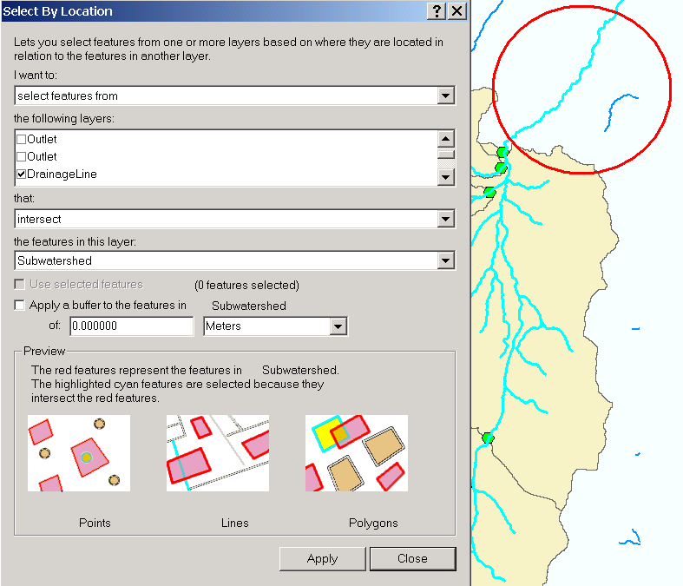
Use the selection tool , hold down shift and unselect the DrainageLine circled in red above that is more out than in the Watershed.
Open the Attribute table of DrainageLine and use Statistics on Shape Length to evaluate the sum of the length of the selected features.
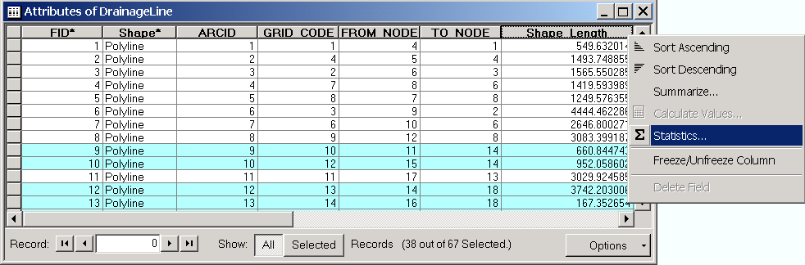
The sum of the length of the selected features is the total length of delineated streams within the watershed. Divide total stream length by area to get the drainage density. Recognize in this calculation that you have neglected the short length of channel just upstream of the outlet. If you want, you can estimate the length of this channel segment and add it back in to the length of streams.
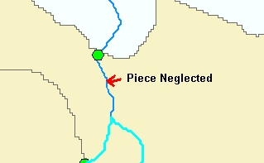
To hand in. Report the drainage density from the channel network delineated using ArcHydro.
2. NHD Network. Use select by location to select the portion of the NHD river network that intersects the Reynolds Creek Watershed. Recognize that the last stream segment extends beyond the watershed so you may optionally unselect it and be ready to add back the piece that is neglected or include this and subtract what you estimate is extra.
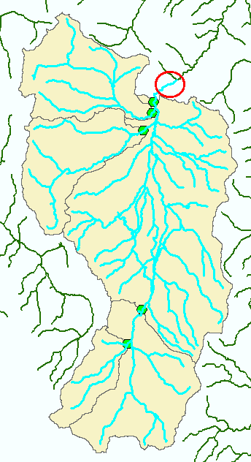.
Open the Attribute table of NHD Route.rch.
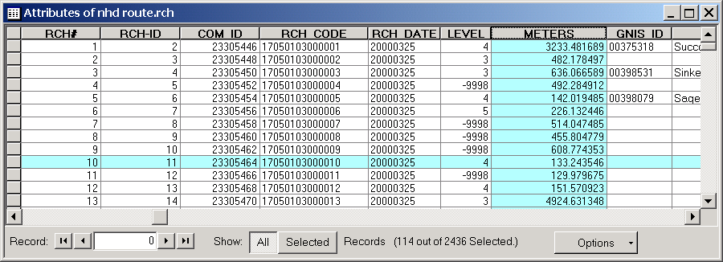
This includes a field METERS that was provided as part of the dataset and is presumably length in meters. Use Statistics on this field to obtain the sum of total stream length. It is uncertain how reliable this estimate is, because the field METERS is from an outside source. To check this import the selected portion of nhd Route.rch into a geodatabase. The GIS will then calculate length. Right click on the nhd route.rch theme and Data|Export Data
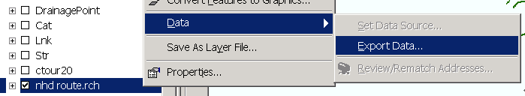
Set the output feature class to comprise Selected features and be added to the Layers feature dataset within the personal geodatabase.
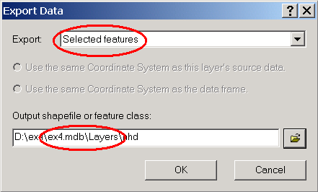
Open the attribute table of the new nhd feature class.
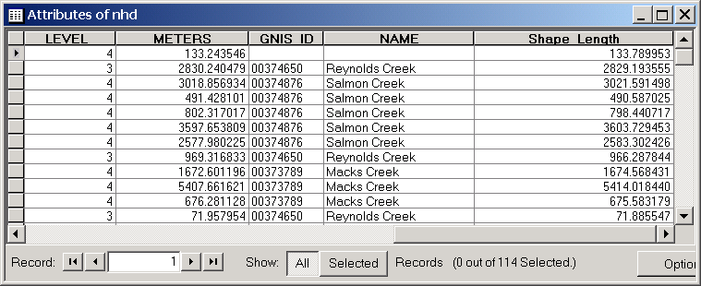
This contains a field 'Shape Length' that is similar, but not identical to METERS. The sum of either of these fields provides an estimate of the total length of streams in the NHD stream network for Reynolds Creek. Divide total stream length by area to get the drainage density.
To hand in. Report the drainage density from the NHD channel network.

Summarize results.
To hand in. Prepare a layout where you compare side by side the NHD channel network, a DEM derived channel network from ArcHydro and a DEM derived channel network from TauDEM. Include contours on the layout so you can judge which channel network is most consistent with the contour crenulations. Report the threshold parameters used in ArcHydro and TauDEM to obtain the channel network you display and provide a table summarizing the total stream length and drainage density for each network presented. Comment on which stream network seems most consistent with the contour crenulations.
Ok, you’re done!

Summary of Material to be Turned In
1. Report the grid cell size in both N-S and E-W directions of a 1/3" grid cell at latitude 43ºN.
2. Make a screen capture of the attribute table of Fdr and give an interpretation for the values in the Value field using a sketch.
3. A layout showing the delineated Catchments and DrainageLines
4. How many DrainagePoints, DrainageLines and Catchments are there? What is the ID field in each feature class that associates the appropriate DrainagePoint with its DrainageLine and Catchment? Make a graphic showing how one associated DrainagePoint, DrainageLine and Catchment are related.
5. A graphic showing drainage paths traced over the digital elevation model.
6. A graphic showing an Identify enquiry on the Flow Accumulation Grid
7. What is the flow accumulation in number of cells where the stream leaves this watershed. What is the cell size? What drainage area does this correspond to in km²? Draw a series of 5 x 5 grids on paper and based upon the template given fill in the following information
- Initial elevation
- AGREE conditioned elevation
- Pit filled elevation
- Flow direction (depict with arrows)
- Flow accumulation area
8. A graphic showing the Region of Hydrologic Influence of your chosen catchment.
9. A graphic of the delineated subwatersheds, and a table showing the subdrainage area and the total drainage area in km² for each gage and for the basin as a whole.
10. Prepare a layout map of Reynolds Creek showing the TauDEM delineated channel network and watersheds draining to each stream segment. On this layout indicate stream orders in different colors or symbols.
11. Report the threshold selected by the constant drop procedure with the DEM curvature based method for Reynolds Creek.
12. Report the contributing area threshold selected by the constant drop procedure with the Contributing area method.
13. Report the drainage density identified from the constant drop procedure with the curvature based and contributing area methods.
14. Report the drainage density from the channel network delineated using ArcHydro.
15. Report the drainage density from the NHD channel network. .
16. Prepare a layout where you compare side by side the NHD channel network, a DEM derived channel network from ArcHydro and a DEM derived channel network from TauDEM. Include contours on the layout so you can judge which channel network is most consistent with the contour crenulations. Report the threshold parameters used in ArcHydro and TauDEM to obtain the channel network you display and provide a table summarizing the total stream length and drainage density for each network presented. Comment on which stream network seems most consistent with the contour crenulations.

