Correction to

Watershed and Stream Network Delineation

GIS in Water Resources, Fall 2011

Prepared by David Tarboton, Utah State University

Page 27 at the point where Strahler Stream Order is inserted into a new field in the DrainageLine and CatchPoly feature class attribute tables.
Select Table Options Joins and Relates Join, then specify the Join data as follows
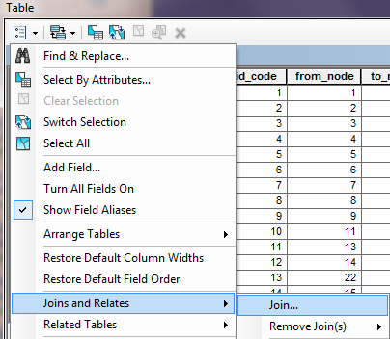 | 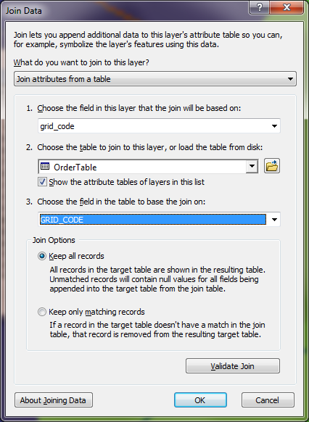
Respond No to the prompt about indexing.
The DrainageLine table now displays many more columns because it has included all the columns from OrderTable. Which of these contains the Strahler Stream order that we need. It may initially be puzzling as to why the MIN and MAX are different, because each link is supposed to have a single Strahler Order. However, when you recognize that a link extends at its junction into the grid cell represented by the downstream link, the reason becomes apparent. Given this it seems best to select the MIN field from OrderTable to assign values for StrahlerOrder. If you appear to be getting unexpected results, check your DrainageLine polygon. If at step 8 you forgot to uncheck the simplify polylines setting, the simplification can result in this process picking up some unexpected stream orders.
Right Click on the StrahlerOrder field header and select Field Calculator, then double click on the OrderTable.MIN OrderTable.MAJORITY field so that the Field Calculator displays as follows and click OK.
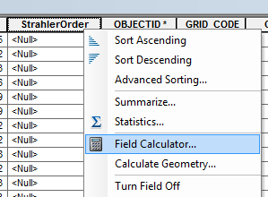 | 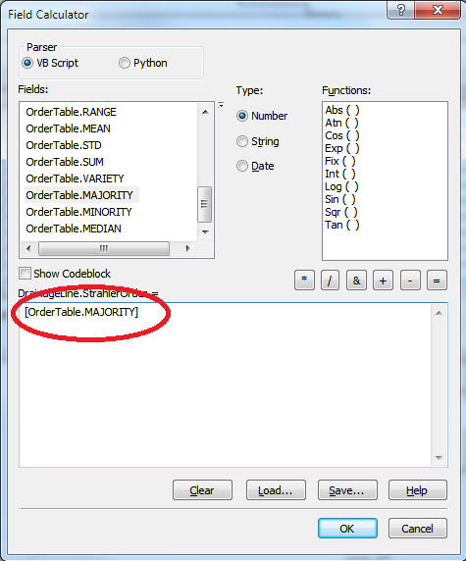

The reason for doing this is that it can and does occur that a stream on a higher order grid flow path "touches" the corner of a grid cell of lower order and the MIN statistic picks this up. The MAJORITY statistic is more robust as it indicates the grid value of the majority of grid cells intersecting the flowline. The following figure illustrates the specific problem.
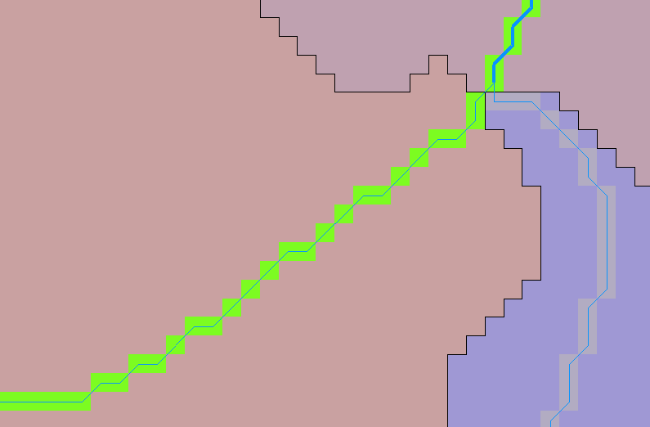
This is a 3rd order stream according to the grid, but has OrderTable.MIN = 1, presumably due to touching this first order grid cell indicated
The calculation StrahlerOrder = OrderTable.MAJORITY resolves this.
OrderTable.MAJORITY should also be used in the next step where Strahler Stream Order is assigned to CatchPoly features.

