CEE6440 Final Exam Fall 2010
GIS in Water Resources

There are three questions on this exam. Do all three questions. For the first two questions, prepare a 2-page typed theme paper. This is two pages for each question for a total of four pages. For the third question use ArcGIS (and Excel/Word) to prepare the map and answers requested. Staple all three solutions together in the order of the questions, and turn in the result to Dr Tarboton in ENGR 225 or the CEE secretary in EL211, by 5PM on Friday, December 10. This is a take-home exam. You are honor bound not to discuss this exam with your colleagues in the class. Your answers should be the result of your work and thought alone. Be assured that if essentially the same idea appears in answers from more than one person, it is fairly easy to recognize that when the grading is being done. If that happens, it is not clear from whom the idea originated and who is just using somebody else’s knowledge. So, keep your ideas to yourself!

The term papers that you choose to describe in answering Questions 1 and 2 should be mutually exclusive, that is, if you focus on particular term papers in answering one of the questions, don’t focus on the same papers when answering the other question. The term projects can be found at:
- Texas: http://www.ce.utexas.edu/prof/maidment/giswr2010/docs/termprojlist.htm.
- Utah: http://www.engineering.usu.edu/dtarb/giswr/2010/students.html.
- Nebraska: Nebraska term projects are delayed so please complete the examination based on Utah and Texas term projects.
You are encouraged to look at term projects from all locations in preparing your answers since this will give you a greater body of information to speak from.

What we are looking for in grading your answers to the first two questions is:

- Knowledge of the facts. Make sure you lay out the facts of what has actually been done before you start offering opinions about what could have or should have been done. This particularly applies to the discussion of term papers. Make sure you discuss what was actually done in the term paper not just about the general subject itself.
- Thoughtful evaluation. How do you evaluate the advantages and limitations of the principles, methods and data that have been used? How does the knowledge you’ve learned in this class relate to the world around us? I am looking for a sense of reflection here, of seeing you set individual situations and facts in a larger context in an intelligent way.

Questions

1. Compare and contrast two papers dealing with the same theme

Choose two term papers that deal with the same or similar themes or topics. Neither of these papers should be your own term paper. The papers that you choose may be from any of the three participating universities. Briefly summarize the contents of the papers (the problem examined, the method of analysis, the results achieved). Compare and contrast the approaches to the problem that the two papers took. Which technical approach do you think was more effective? Why? Which paper does a more effective job of communicating its results? Why? Suppose you were undertaking a study of this same subject. Having studied these two papers, what have you learned about how to go about your investigation effectively? What would you do differently from what the authors of these papers did?

2. Write an assessment of the utility of GIS in a particular application area

Student term papers on a range of topics have been presented. Select four papers that fall within a similar subject area and present a critique of how effective GIS is in its application in this subject area. What is the scope of the application area? How has GIS been used? What types of problems have been solved effectively? What limitations exist that have yet to be overcome in the application of GIS in this area? In your answer, you must refer specifically to work presented in term papers prepared in this course. In other words, I am not looking here just for a general statement about your opinions in the field but rather a deduction based on the term papers presented in this class of what has been done and how you judge the effectiveness of that. The papers that you select for this question may be from any of the three participating universities. You are encouraged to look at and use papers across all the universities, where they address similar subject areas.

3. Snow in the Logan River Basin

Background and Context.
Snow is an important water resource in the Western U.S. For this reason the NRCS has a network of SNOTEL sites that monitor snow across the west. There are seven SNOTEL stations in the vicinity of the Logan River. Over the 2010 Thanksgiving weekend there was a considerable snowstorm in Northern Utah. Snow Water Equivalent (SWE) totals recorded at the area SNOTEL stations are tabulated below.

SNOTEL Station | Lat | Long | SWE (inches) on 2010-11-28: 1900
Tony Grove Lake | 41.9000 | -111.6333 | 10.8
Klondike Narrows | 41.9683 | -111.5967 | 6.1
Garden City Summit | 41.9217 | -111.4681 | 6.8
Temple Fork | 41.8000 | -111.5500 | 4.8
Tony Grove RS | 41.8844 | -111.5689 | 2.7
USU Doc Daniel | 41.9000 | -111.5167 | 8.8
Franklin Basin | 42.0494 | -111.5994 | 8

These data are from http://www.wcc.nrcs.usda.gov/snotel/Utah/utah.html and an equivalent website for Idaho. Snow Water Equivalent (SWE) is a standard snowpack measurement made at SNOTEL sites via a pressure-sensing snow pillow. It is the amount of water contained within the snowpack. It can be thought of as the depth of water that would theoretically result if you melted the entire snowpack instantaneously. The figures following give SWE data for two of these sites. It is common for snow accumulation to increase with elevation. The variability in snow accumulation at the above stations is in part due to elevation, a question we will examine in this exam.
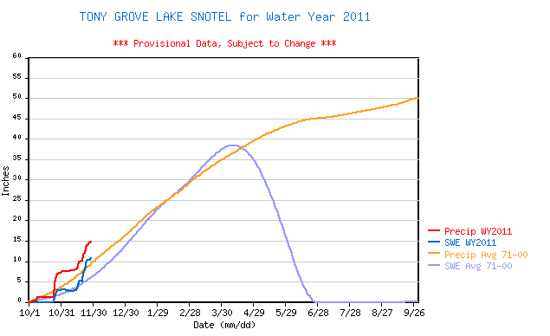

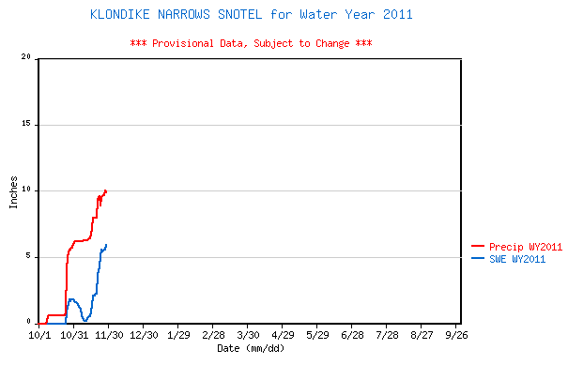

Data.
The zip file final.zip (http://www.engineering.usu.edu/dtarb/giswr/2010/Final.zip) contains the data you will need for this problem. The contents when unzipped include
- A 30 m DEM for this region derived from the National Elevation Dataset (logan.tif)
- An Outlets shapefile (LoganOutlet.shp)
- An Excel spreadsheet (snotel.xls) giving SNOTEL data on 11/28/2010 at 19:00. Use the NAD83 Datum for Lat and Long coordinates in this spreadsheet.

Questions
This problem requires you to use ArcGIS tools to delineate the Logan River watershed upstream of the outlet, develop a regression relationship relating SWE accumulation to elevation and estimate the volume of water present in the form of snow in the Logan River Basin at the time indicated.

- Delineate the watershed for the Logan River upstream of the point in the shapefile "LoganOutlet.shp". Report the drainage area in m². (You should fill sinks, but DEM reconditioning is not required)

- Delineate a stream network using a support area threshold of 1000 grid cells. Determine the total length of streams in this stream network.

- Prepare a layout showing the Logan River stream network, watershed and elevations attactively labeled and presented, with title, legend scale and north arrow. Include the SNOTEL stations on this layout labeled with their names.

- Use the DEM to determine the elevation of each SNOTEL station. The Zonal Statistics as Table tool may be helpful here. Present your results in a table where you show the elevation of each SNOTEL station.

- Prepare a graph of snow water equivalent versus elevation and use linear regression in Excel to develop a relationship giving snow water equivalent as a function of elevation.

- Use this regression relationship to estimate the snow water equivalent from DEM elevations using Raster Calculator and prepare a map (presented as a layout) that shows the estimated depth of snow over the Logan River watershed based on this relationship. It may occur that you obtain negative snow water equivalent values at low elevation. These should be interpreted as locations where there is no snow and indicated on your map.

- Estimate the total volume of water (in m³) present in the form of snow in the Logan River watershed from this map.

