Error in Darcy Experiment Example Animation
There is an error in the evaluation of Reynolds number in the Darcy Experiment Animation in Chapter 4 of the Online Module http://hydrology.usu.edu/rrp. This occurs right at the end of the animation.

The equation for evaluation of Reynolds number for flow through a porous medium is (Equation 23)
$$Re=\frac{ρqd}{μ}$$
The workbook mistakenly uses $ρq=γ$ which is incorrect because this is a q not a g. The numerical values given in the animation displayed below are wrong, as a result of this. Evaluating the numerical values displayed below does not result in the numerical result given, which is correct.
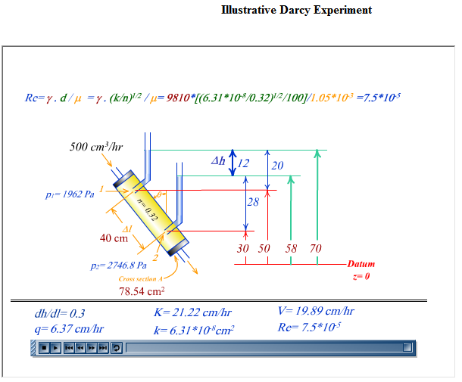
These numbers are incorrect and do not evaluate to the result given. See correct evaluation below
γ in these formula's, should be ρq
The correct evaluation of this formula is
$$Re=\frac{ρqd}{μ}=\frac{ρq{\left(\frac{k}{n}\right)}^{\frac{1}{2}}}{μ}=\frac{1000×\frac{6.37}{100×3600}×{\left(\frac{6.31×{10}^{-8}}{10000×0.32}\right)}^{\frac{1}{2}}}{1.05×{10}^{-3}}=7.48 ×{10}^{-5}$$
Units are
$$\frac{kg m^{-3}×\frac{cm h^{-1}}{cm m^{-1}× s h^{-1}}×{\left(\frac{cm^{2}}{cm^{2}m^{-2}}\right)}^{\frac{1}{2}}}{N s m^{-2}}=\frac{{kg m s}^{-2}}{N}=dimensionless$$
Verifying this in Excel, the formula is
=1000*6.37/(100*3600)*SQRT(0.0000000631/(10000*0.32))/0.00105
which evaluates to
7.4832E-05

